# Truck Warranty Snowflake Intelligence Hands on Lab

Table of Contents

Truck Warranty Snowflake Intelligence Hands on Lab 1

Overview 2

Data 2

Agenda 3

Lab Setup 4

Get Setup Script 4

Set Environment 4

Load the files to stages 5

Load Tables 7

Verify Data 8

Create Warranty Analyst 10

Load the Tables 11

Create the Joins 12

Add Synonyms 14

Add Custom Instructions 15

Save Verified Queries 16

Optional Additional Queries 25

Build Search Service on TECHNICIAN_NOTES with the GUI 28

Test TECHNICIAN_NOTES_SEARCH 33

Create Document Search Service with SQL 34

Extract Text 35

Chunk Text 35

Create Search Service 36

Build Agent 37

Enable Snowflake Intelligence (if needed) 38

Add Analyst Tool 42

Add First Search Service Tool 43

Add Second Search Service Tool 44

Add Orchestration Instructions 46

Test Agent 48

Snowflake Intelligence 49

First Question (compare notes to procedures based on model) 50

Question Two (End to End Analysis and Executive Summary) 52

Conclusion 53

## Overview

**Titan Motors**, a commercial truck manufacturer, utilizes a network of 50 national dealers that both sell and service their vehicles. The VP of Warranty Operations has identified a concerning trend: warranty claim costs are rising significantly, but the root cause is unclear. With thousands of service transactions annually—each containing structured data (revenue, parts, dates) and unstructured content (technician notes)—plus vehicle-specific diagnostic manuals and warranty policy guidelines, a traditional investigation would take weeks of manual effort by fraud analysts and technical auditors. The VP needs to quickly identify suspicious patterns, policy violations, and potential fraud, then develop an actionable remediation plan with estimated financial impact.

In this workshop, you'll build a **Snowflake Intelligence Agent** that performs this complex investigation in minutes instead of weeks. By combining **Cortex Analyst** (for analyzing structured sales and service data), **Cortex Search** (for examining thousands of technician notes and searching diagnostic manuals and warranty policies), and an **AI Agent** (to orchestrate the investigation and correlate findings), you'll uncover multi-layered fraud evidence: dealers with statistically abnormal warranty revenue, systematic documentation quality failures, maintenance violation patterns, and specific policy non-compliance. The agent delivers what executives need: actionable recommendations with specific claims to audit, financial recovery estimates across multiple scenarios, and a timeline-based remediation plan—all through natural language queries that require no SQL expertise.

### Data

Our data comes from a variety of sources. First, structured data is stored in our Dealer Operations database. This contains 5 tables and track sales and service records for our trucks sold and serviced within our dealer network.

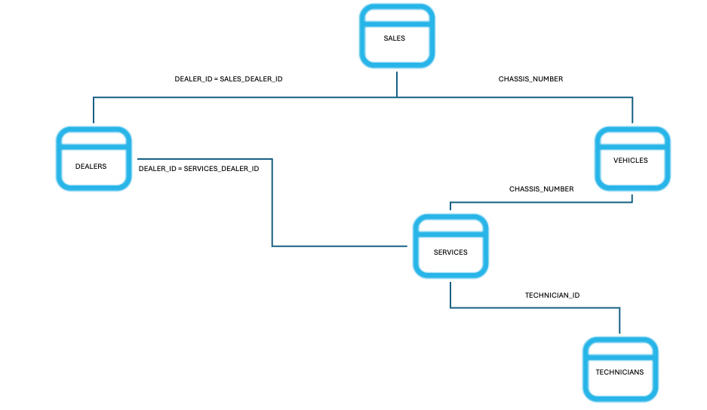

Within the Services table are Technician Notes, recording how they diagnosed and ultimately fixed assigned warranty claims. This is also where they record notes from ongoing maintenance services and non-warranty repairs.

Finally, we have our documents. This includes 5 Model Specific Service/Diagnostic Guides plus our Warranty Policy Document.

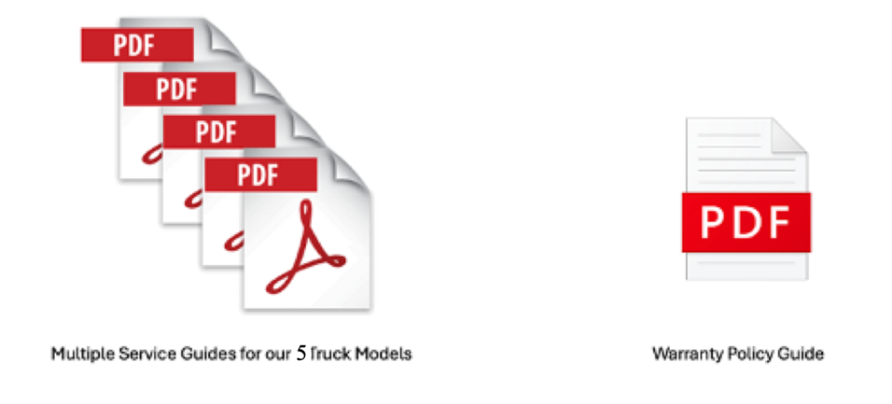

Workshop Roadmap

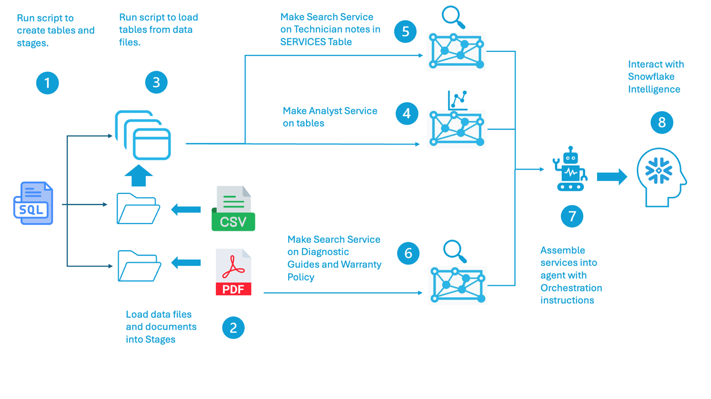

### Agenda

1. Create and test Analyst Service (20 mins)
2. Create Search Service on Technician Notes using GUI (10 mins)
3. Create Search Service on Documents using SQL (10 mins)
4. Assemble and test the Agent (20 mins)
5. Get analysis and recommendations in Snowflake Intelligence (15 mins)

Lab Setup (if not already set up for you)

### Get Setup Script

<https://github.com/azbarbarian2020/truck-warranty-fraud-workshop-V2/tree/main> Navigate to truck-warranty-fraud-workshop-v2/scripts/Workshop_setup.sql and copy the code.

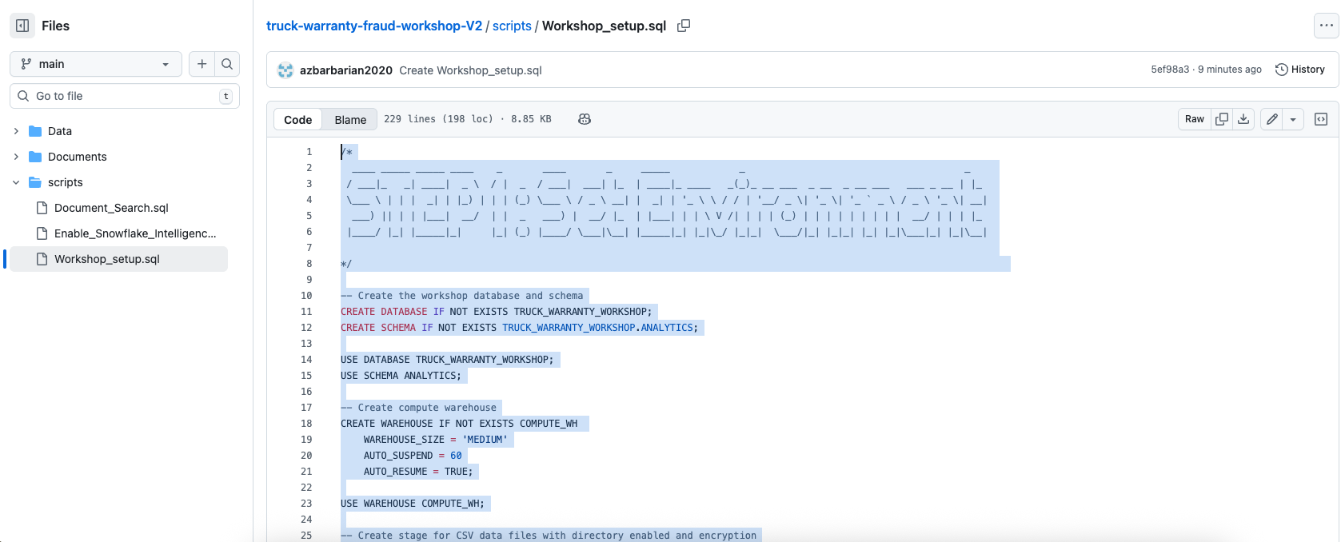

### Set Environment

This creates or sets our Database, Schema, Warehouse and creates our Stages. **Note if you have an existing database, schema or warehouse you want to use, make sure to alter the code accordingly.**

In Snowsite, click **Projects** 🡪 **Workspaces**. Click the **+** button up top to make a new .sql sheet. Paste the code from github. Highlight the code for **Step 1: Set Environment** and **Step 2: Make Tables**. Press the blue run button.

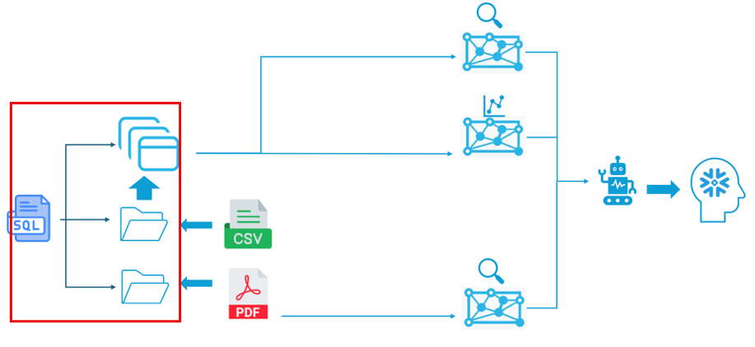

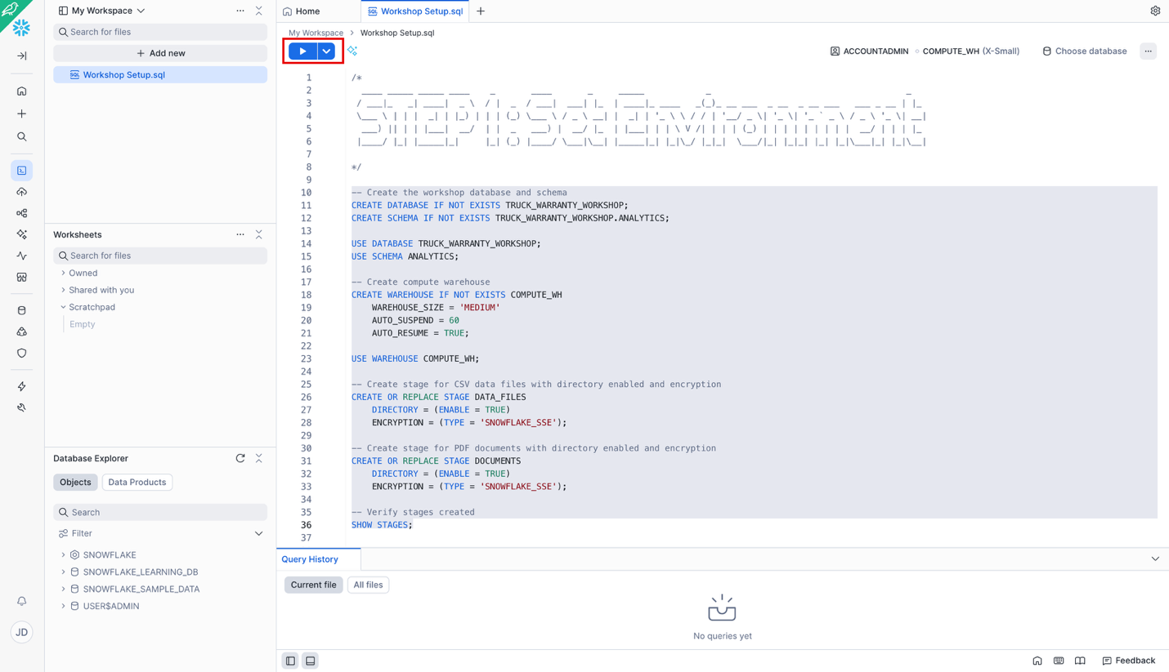

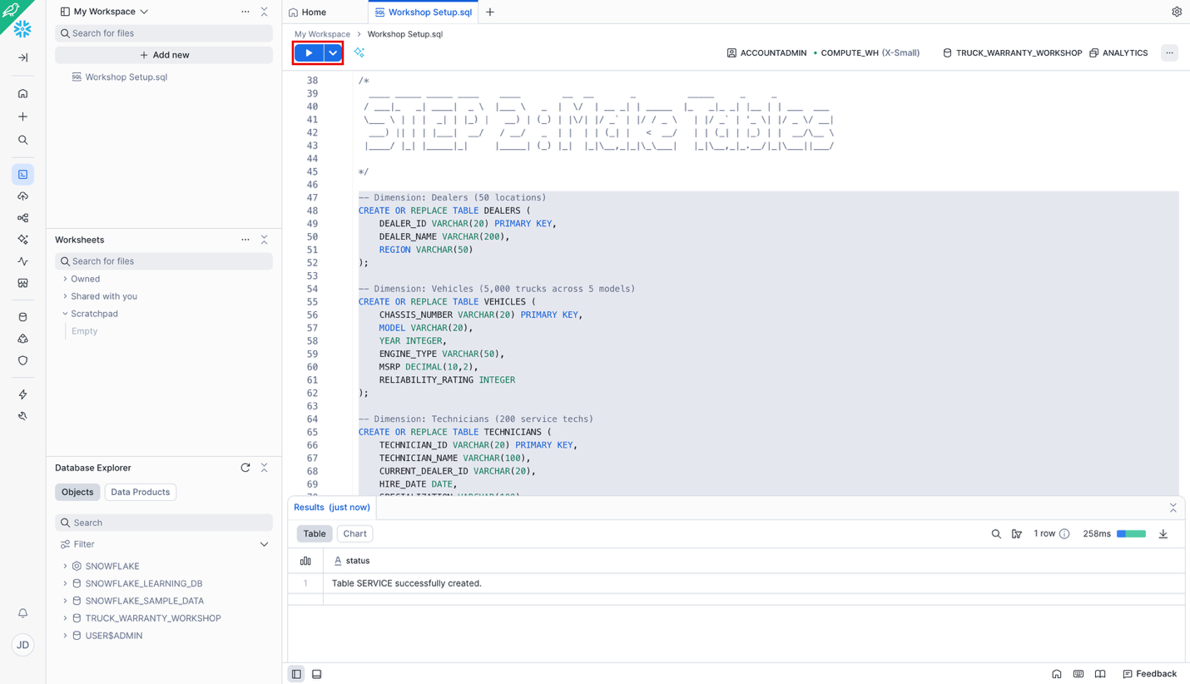

### Load the files to stages

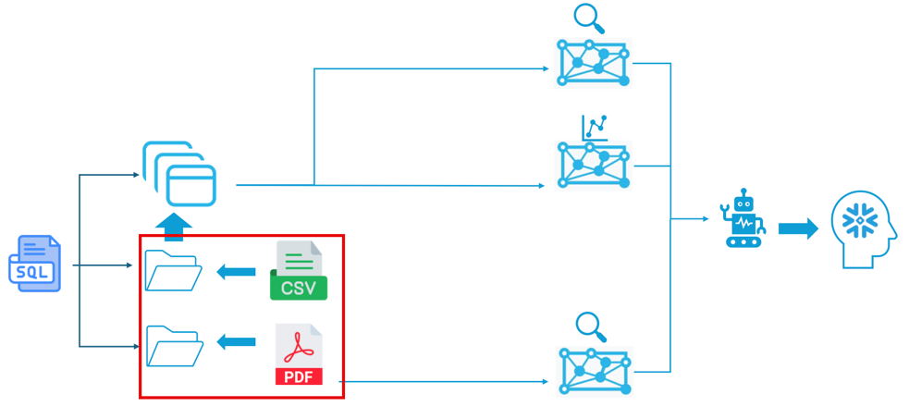

Download the 5 .csv files from truck-warranty-fraud-workshop-v2/data

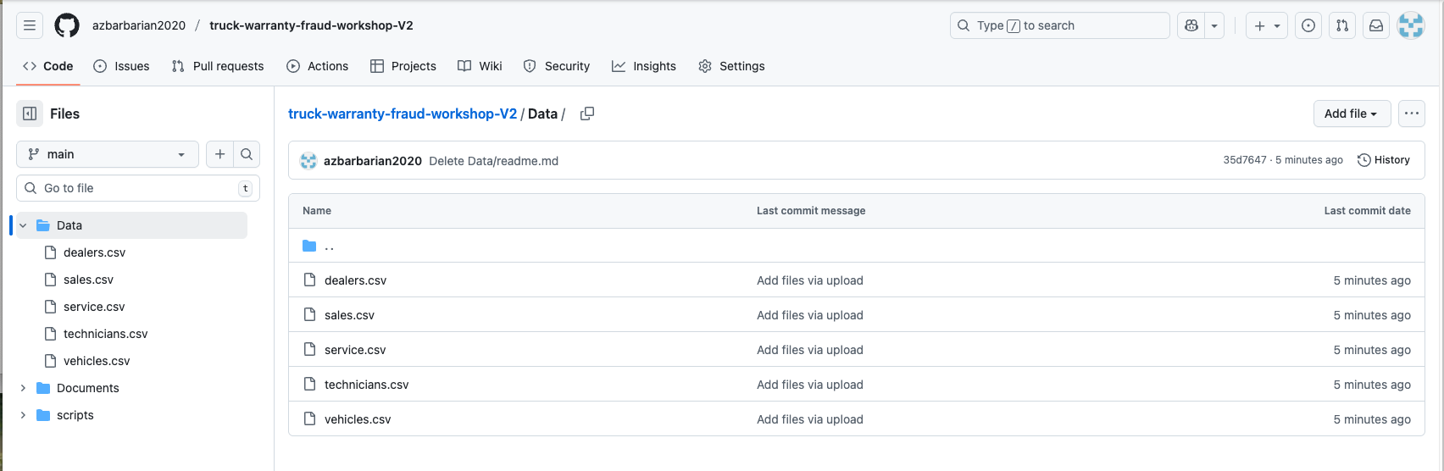

Download the 6 .pdf docs from truck-warranty-fraud-workshop-v2/documents

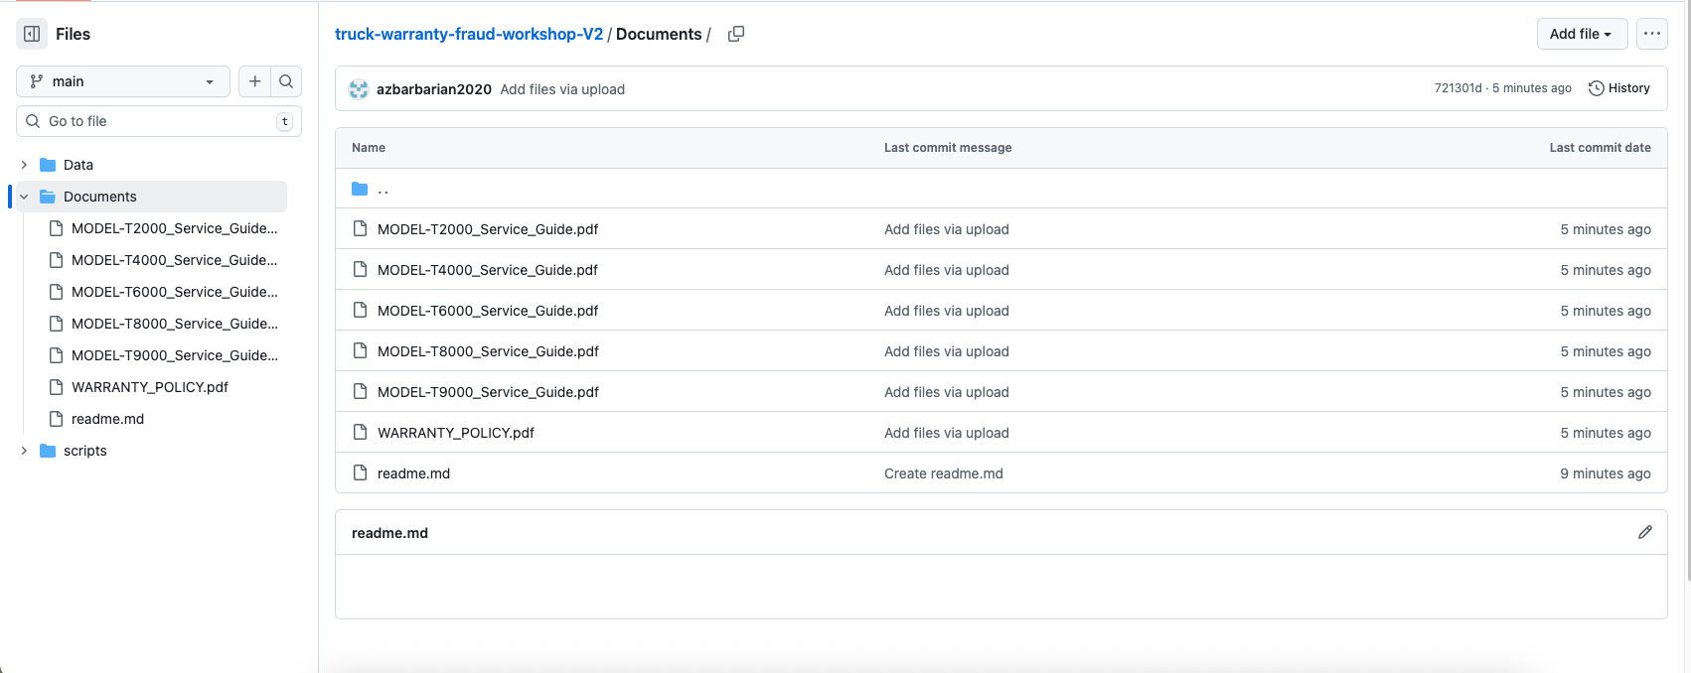

Upload Files

Go to **Catalog** 🡪 **DATABASE_EXPLORER** 🡪 **TRUCK_WARRANTY_WORKSHOP** 🡪 **ANALYTIC** 🡪 **Stages** 🡪 **DATA_FILES**

Click the **+ Files** button and select the 5 .csv data files you downloaded from GitHub.

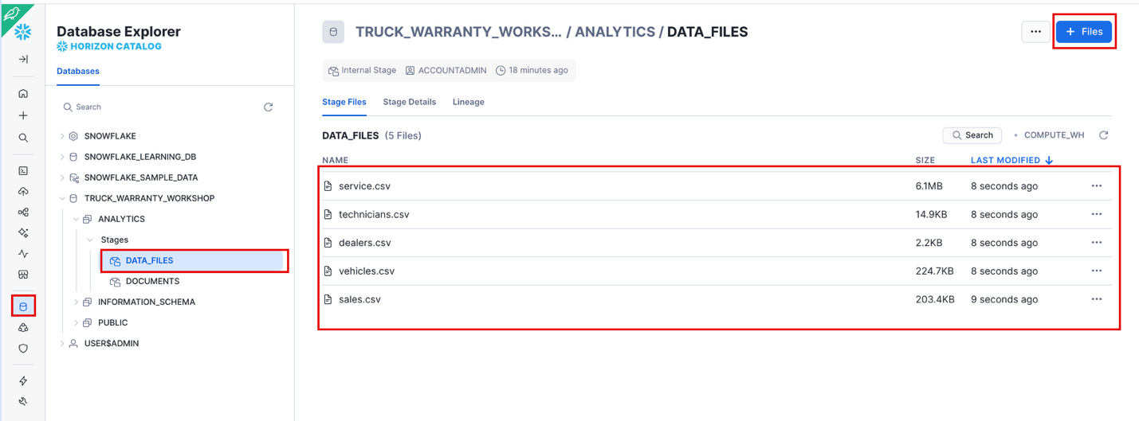

Do the same thing except now upload the 6 .pdf docs you downloaded from Github to the DOCUMENTS stage.

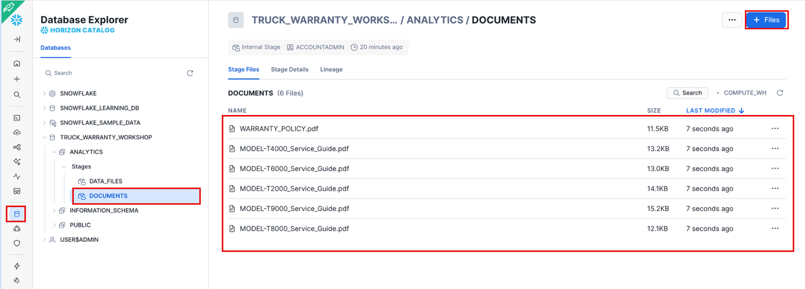

### Load Tables

Highlight the rows under **Step 4: Load Tables**. Note we already did **Step 3** which was to load the files into the stages.

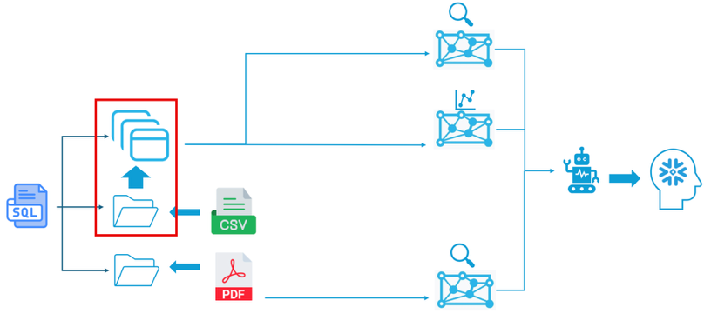

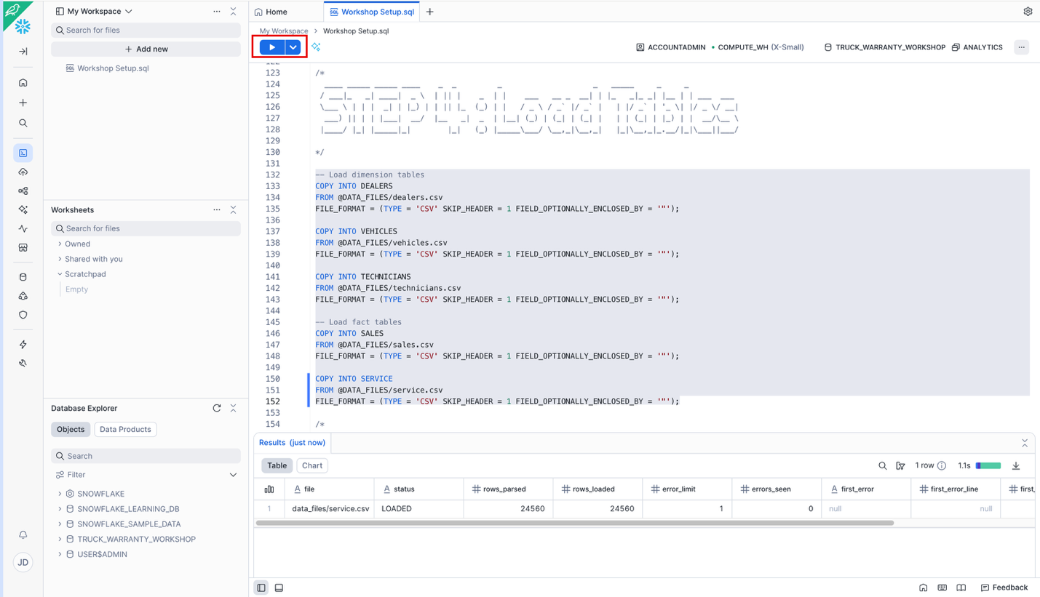

### Verify Data

Run the first query to check the row counts. Make sure your results match the expected results shown.

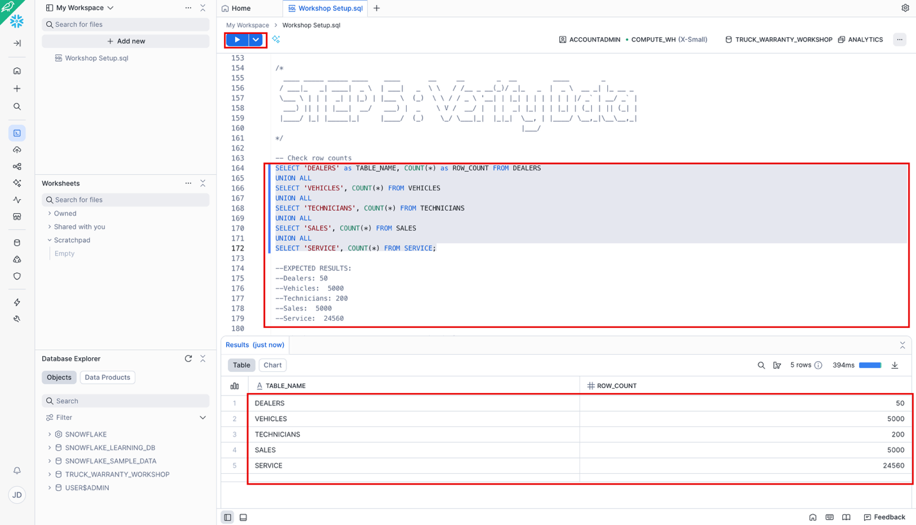

Run the second data validation to check warranty revenue percentages by dealer. Make sure the numbers match what is shown below.

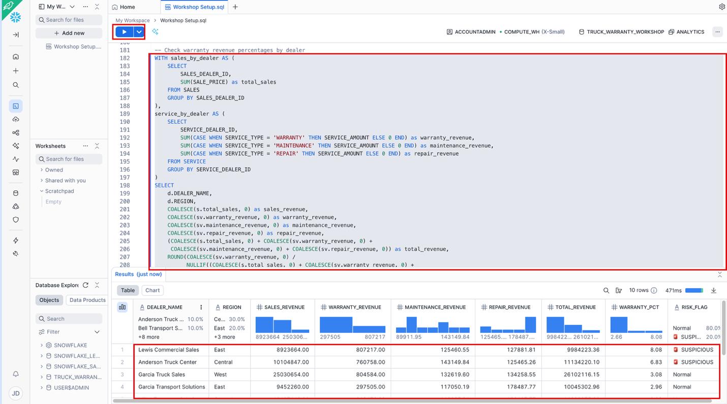

Setup Complete. You are now ready to start your workshop!

## Create Warranty Analyst

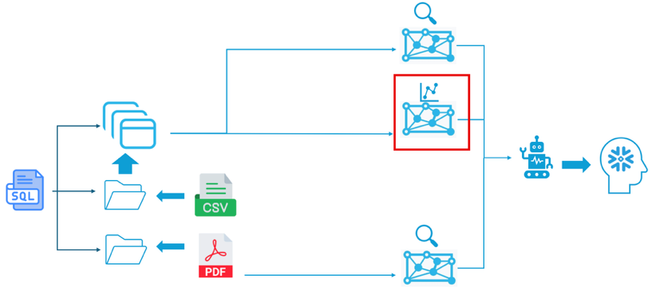

Why Cortex Analyst?

Traditional BI requires writing complex SQL. Cortex Analyst lets users ask questions in natural language and automatically generates accurate SQL. We'll train it to understand our revenue calculations and fraud thresholds.

Go to **AI & ML** 🡪 **Cortex Analyst** 🡪 **Create New** 🡪 **Create new Semantic View**

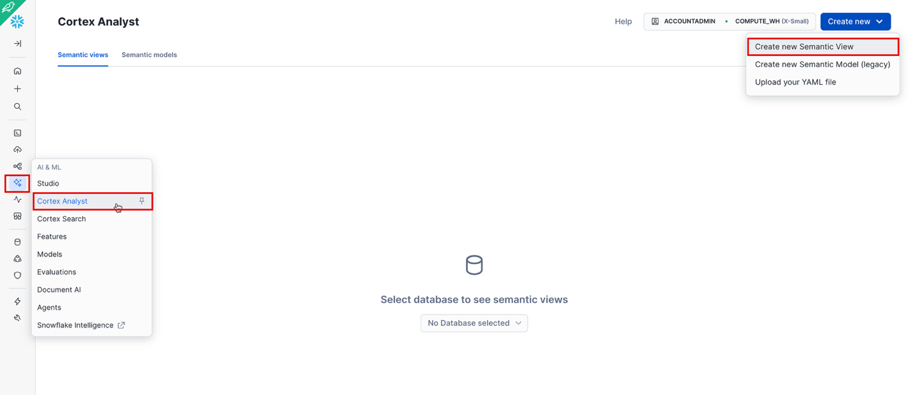

Select the Database and Schema you used or created for the workshop. Name the Semantic view **WARRANTY_DATA_ANALYST**, then click Next.

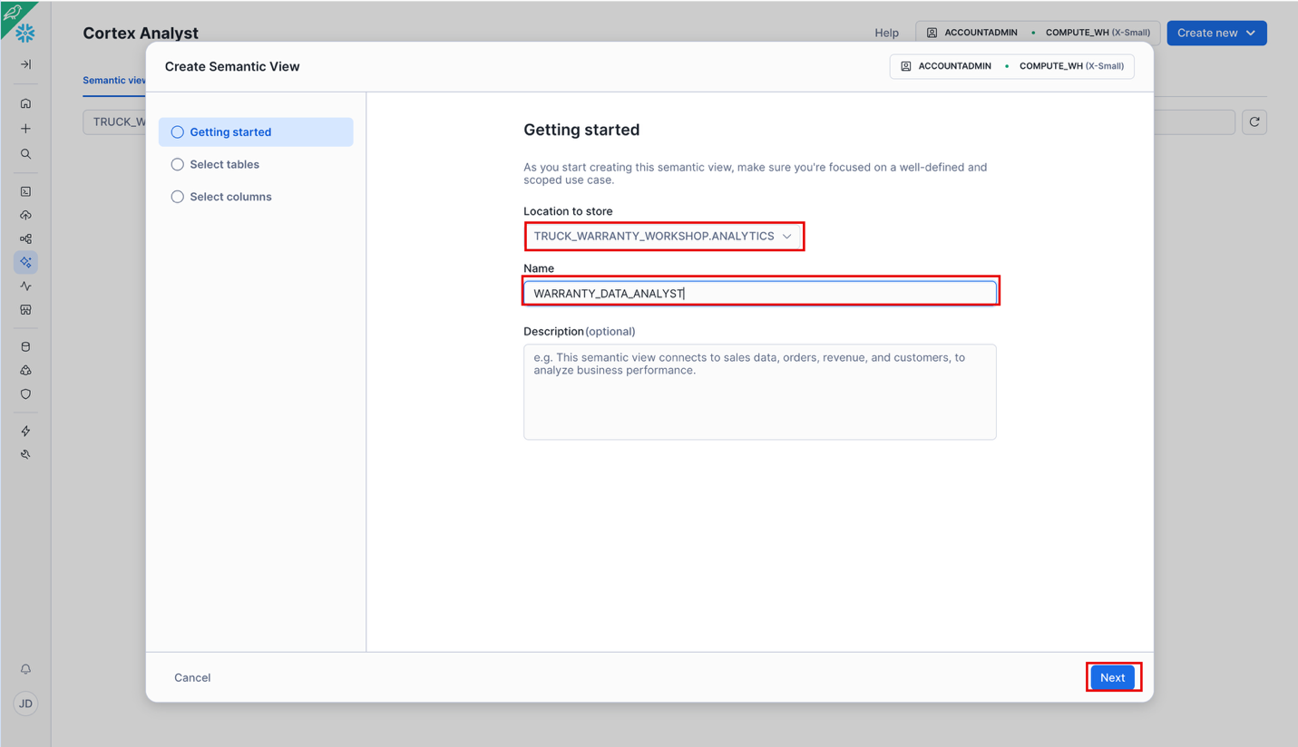

### Load the Tables

Select the 5 tables we created for the Workshop and click **Next**.

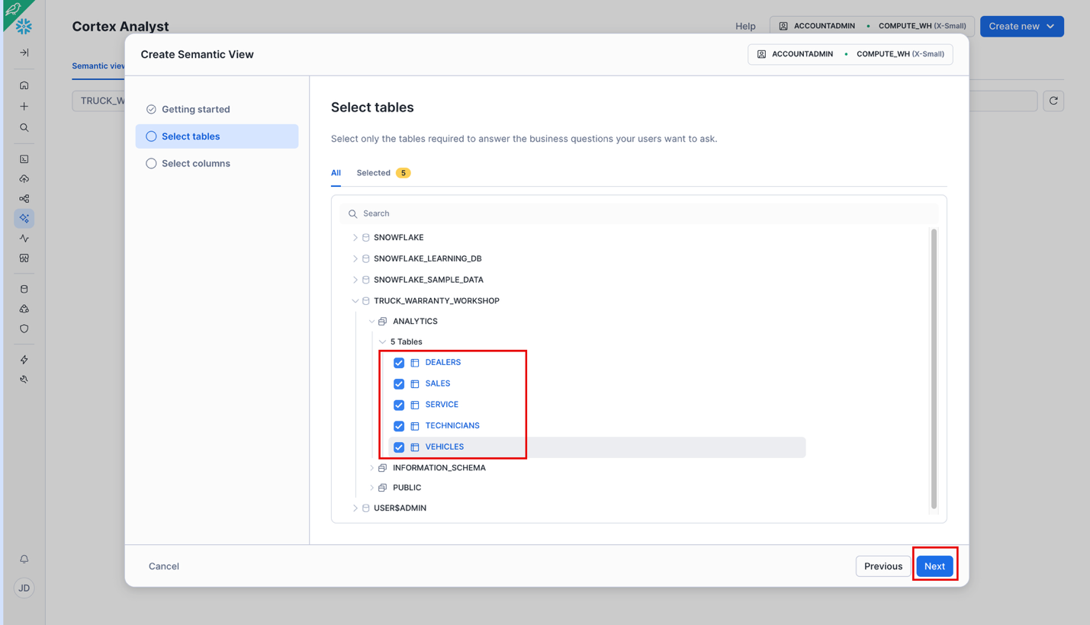

Select all the columns for all the tables and click **Create and Save**.

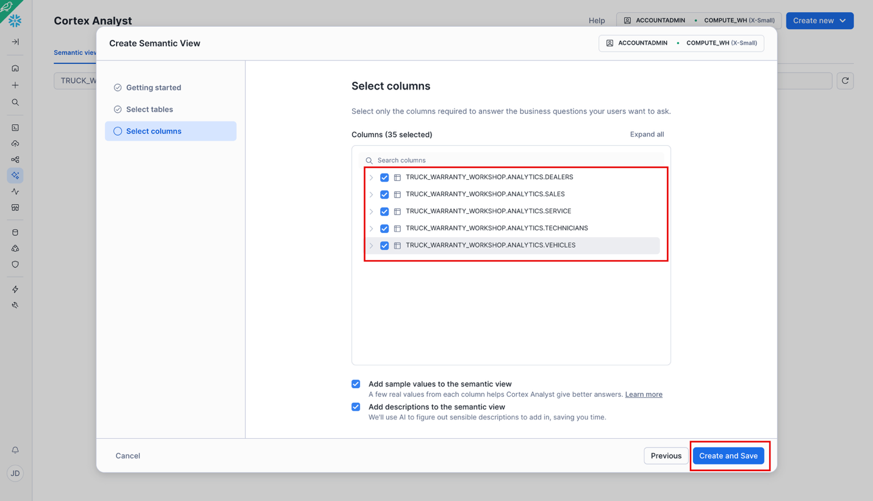

### Create the Joins

Scroll down, click the **+** button in **Relationships**.

Name the Relationship: **SALES_TO_DEALERS**

Left Table: **Sales**

Right Table: **Dealers**

Left columns(s): **SALES_DEALER_ID**

Right columns(s): **DEALER_ID**

Click **Add**

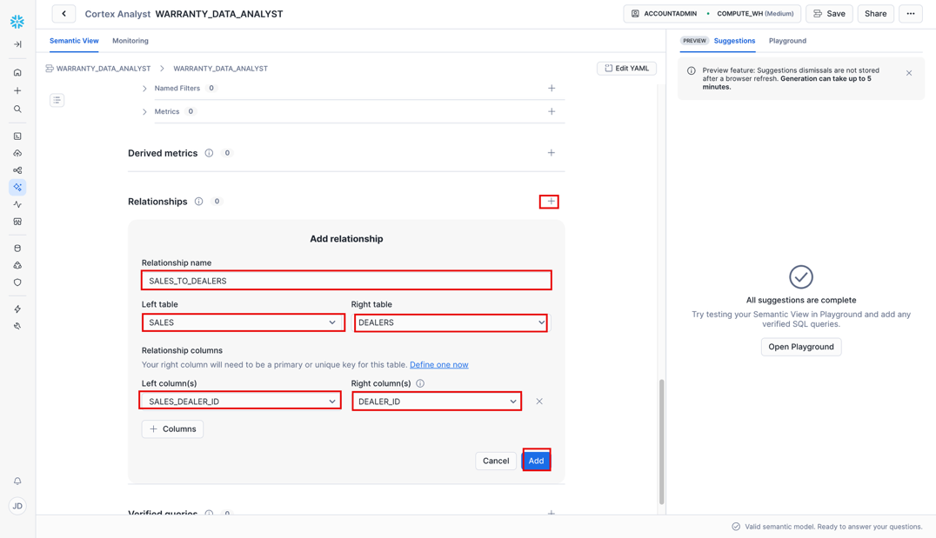

Add the other 4 relationships as shown below.

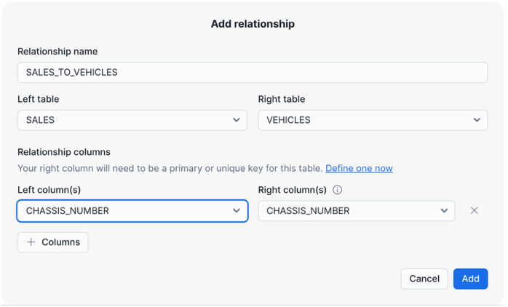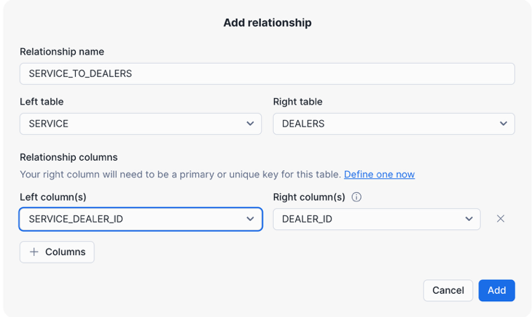

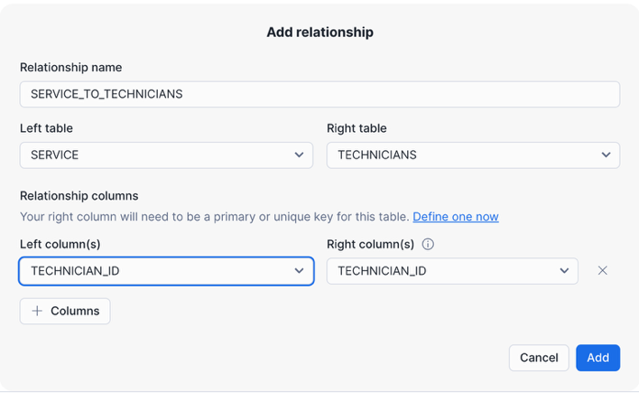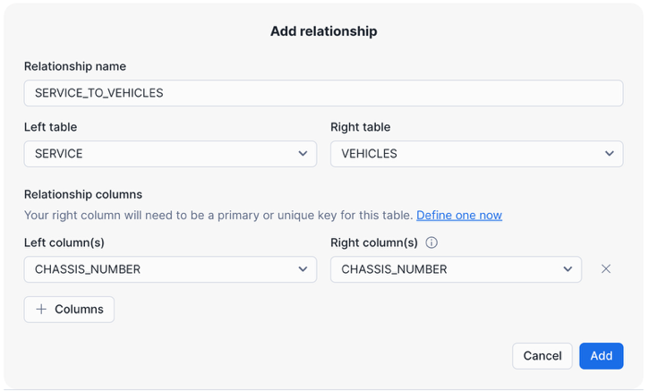

When completed you should have 5 Relationships as shown below. Make sure to **Save** your work.

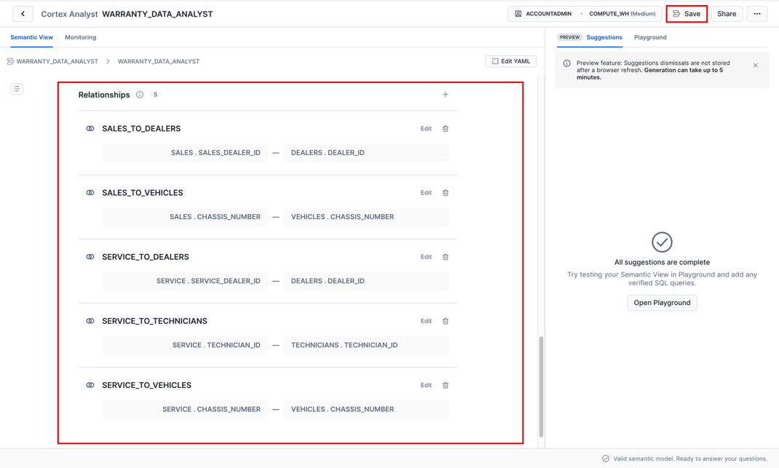

### Add Synonyms

Why Synonyms?

Users might say "revenue" or "claim amount" instead of "SERVICE_AMOUNT". Synonyms help Analyst understand.

Expand the **Facts** of the **Service** Table. Choose **SERVICE_AMOUNT** Click **Edit**. Add the following to synonyms: **revenue, claim amount**. Click **Save** and **Save**

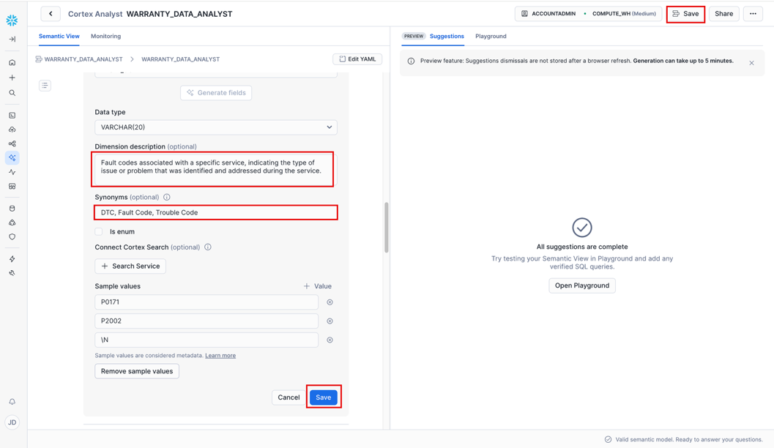

### Add Custom Instructions

At the top of the Analyst window, click edit by Custom Instructions. In the SQL generation window paste the following:

**BUSINESS CONTEXT:**

**You are analyzing a truck dealership network. Revenue comes from four sources:**

**1. Sales revenue (selling trucks)**

**2. Warranty revenue (manufacturer-paid repairs)**

**3. Maintenance revenue (customer-paid preventive service)**

**4. Repair revenue (customer-paid fixes)**

**CRITICAL CALCULATION - Total Revenue:**

**Total Revenue = (Sales Revenue) + (Warranty Revenue) + (Maintenance Revenue) + (Repair Revenue)**

**IMPORTANT: When calculating revenue by dealer, you MUST use CTEs (Common Table Expressions) to pre-aggregate sales and service data separately BEFORE joining to dealers. NEVER join SALES to SERVICE directly as this creates cartesian products and inflates totals.**

**The correct pattern is:**

**1. Create a CTE that aggregates SALES by SALES_DEALER_ID**

**2. Create a separate CTE that aggregates SERVICE by SERVICE_DEALER_ID and SERVICE_TYPE**

**3. Join DEALERS to both CTEs using LEFT JOINs**

**4. Use COALESCE to handle dealers with no sales or service records**

**FRAUD DETECTION THRESHOLDS:**

**- Normal dealers: 2-4% warranty revenue**

**- Suspicious dealers: 6%+ warranty revenue**

**- High-risk dealers: 7.5%+ warranty revenue**

**When asked about "highest warranty percentage" or "suspicious dealers", filter for dealers with warranty_percentage >= 6.0.**

Click **Apply**, then **Save**

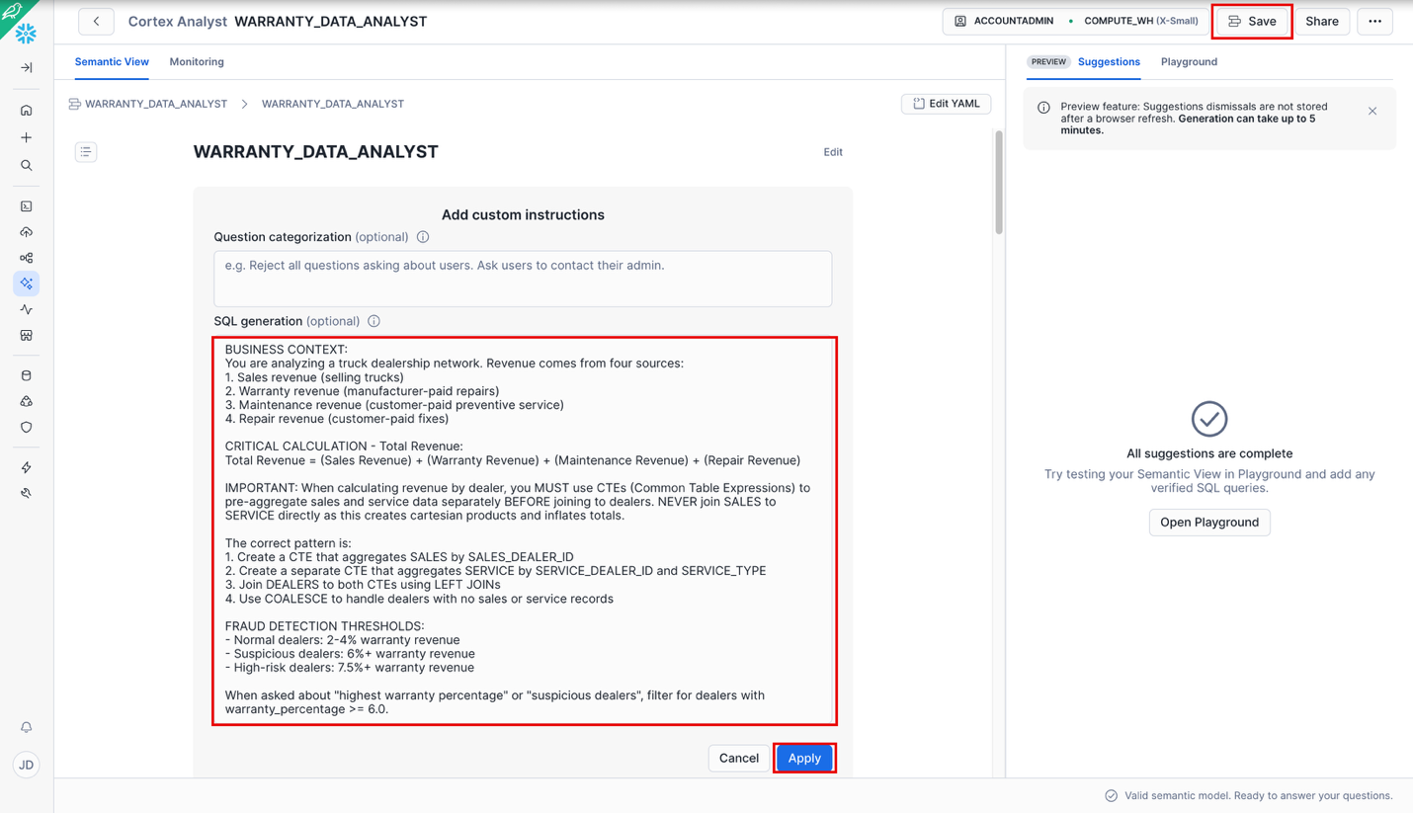

### Save Verified Queries

Why Verified Queries?

These "train" Analyst by showing it example questions and correct SQL patterns.

Click the Playground tab, and paste: **Show me the top 5 dealers with the highest percentage of total revenue coming from warranty revenue.** Click **Run**

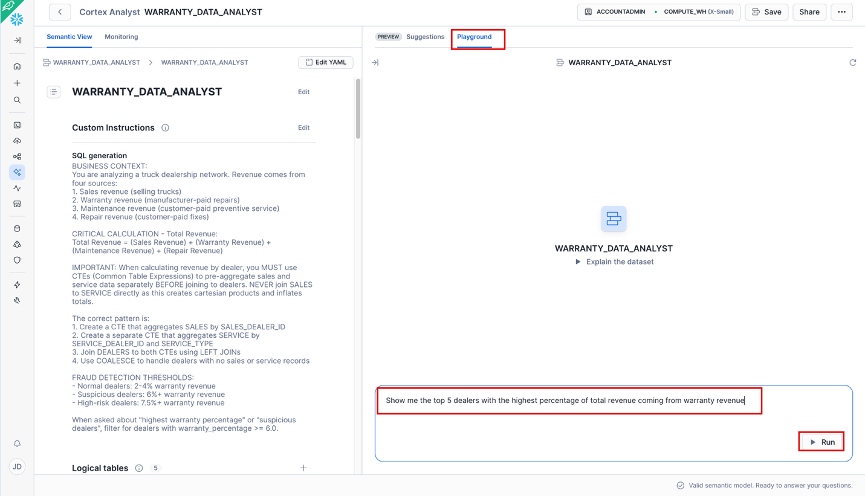

You should see the following results

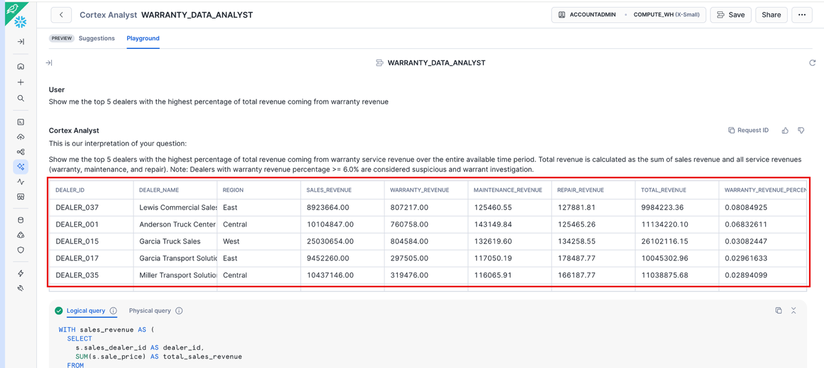

Scroll down and click the **+ Verified query** button.

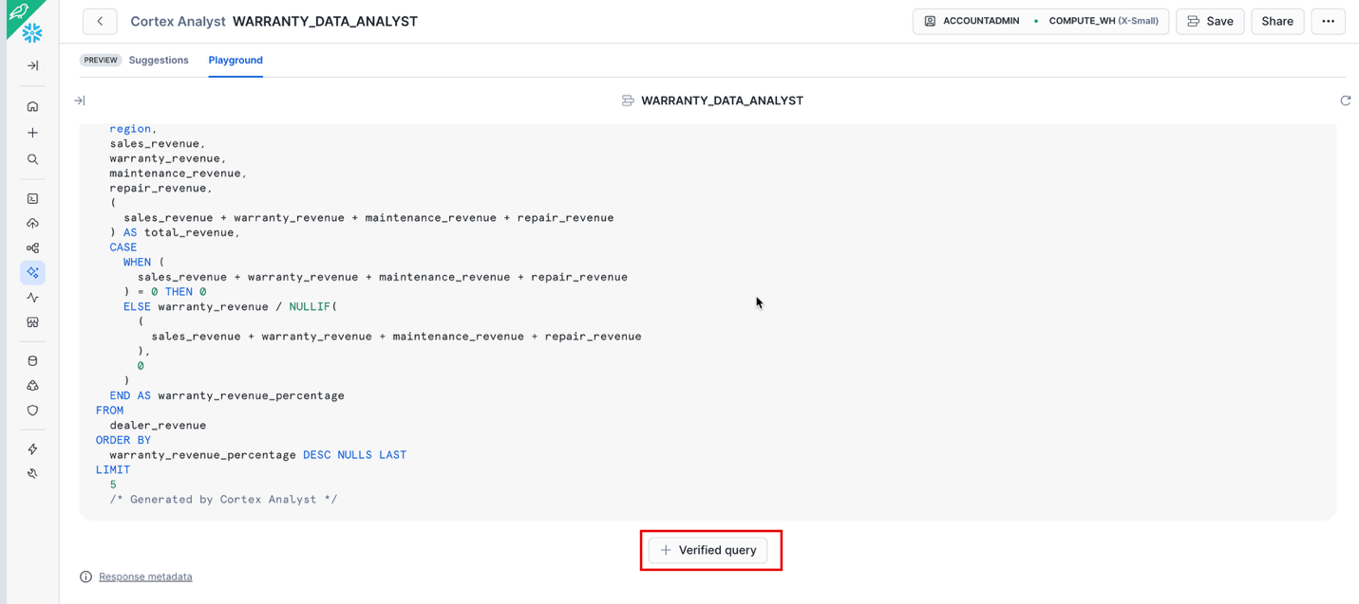

This will open up a window for you to verify the sql (you can change it if Analyst didn’t interpret your question correctly). Click **Save and Continue**.

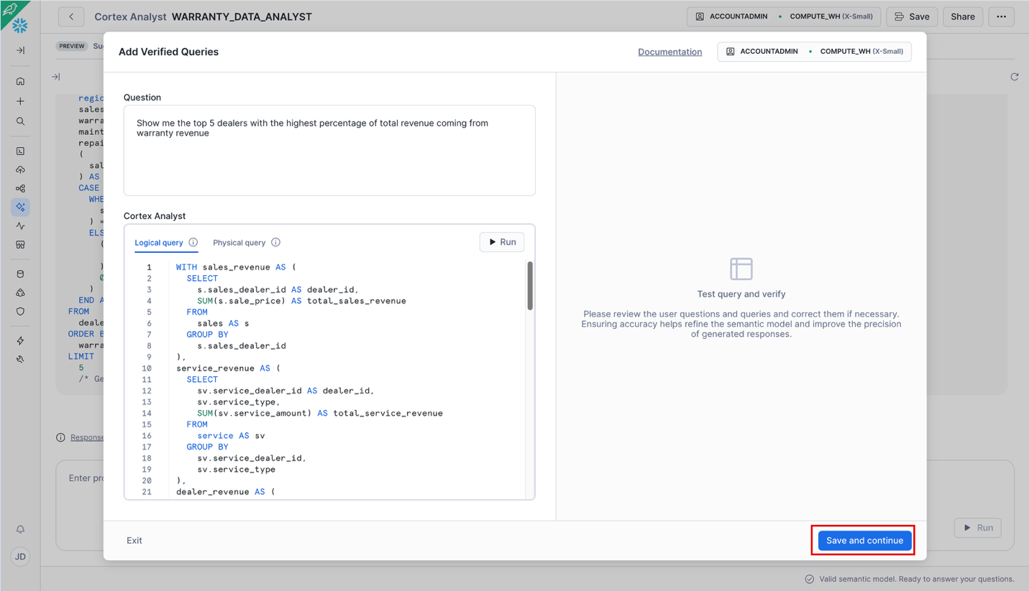

If your results look different, paste this sql:

**WITH sales_by_dealer AS (**

**SELECT**

**s.sales_dealer_id AS dealer_id,**

**SUM(s.sale_price) AS sales_revenue**

**FROM**

**sales AS s**

**GROUP BY**

**s.sales_dealer_id**

**),**

**service_by_dealer AS (**

**SELECT**

**sv.service_dealer_id AS dealer_id,**

**SUM(**

**CASE**

**WHEN sv.service_type = 'WARRANTY' THEN sv.service_amount**

**ELSE 0**

**END**

**) AS warranty_revenue,**

**SUM(sv.service_amount) AS total_service_revenue**

**FROM**

**service AS sv**

**GROUP BY**

**sv.service_dealer_id**

**),**

**dealer_revenue AS (**

**SELECT**

**d.dealer_id,**

**d.dealer_name,**

**COALESCE(sbd.sales_revenue, 0) AS sales_revenue,**

**COALESCE(svbd.warranty_revenue, 0) AS warranty_revenue,**

**COALESCE(svbd.total_service_revenue, 0) AS total_service_revenue,**

**COALESCE(sbd.sales_revenue, 0) + COALESCE(svbd.total_service_revenue, 0) AS total_revenue**

**FROM**

**dealers AS d**

**LEFT OUTER JOIN sales_by_dealer AS sbd ON d.dealer_id = sbd.dealer_id**

**LEFT OUTER JOIN service_by_dealer AS svbd ON d.dealer_id = svbd.dealer_id**

**)**

**SELECT**

**dealer_id,**

**dealer_name,**

**sales_revenue,**

**warranty_revenue,**

**total_service_revenue,**

**total_revenue,**

**CASE**

**WHEN total_revenue > 0 THEN warranty_revenue / NULLIF(total_revenue, 0)**

**ELSE 0**

**END AS warranty_percentage**

**FROM**

**dealer_revenue**

**WHERE**

**total_revenue > 0**

**ORDER BY**

**warranty_percentage DESC NULLS LAST**

**LIMIT**

**5**

Run verify and save these remaining Verified Queries

**What is the revenue breakdown for Anderson Truck Center?**

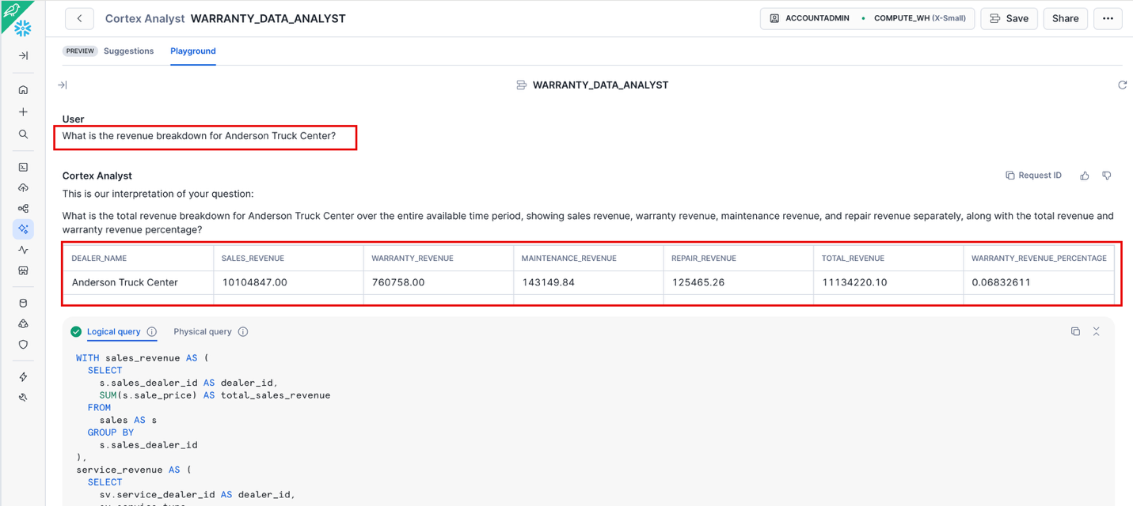

If your results look different, paste this sql:

**WITH dealer_sales_revenue AS (**

**SELECT**

**s.sales_dealer_id AS dealer_id,**

**COALESCE(SUM(s.sale_price), 0) AS sales_revenue**

**FROM**

**sales AS s**

**LEFT OUTER JOIN dealers AS d ON s.sales_dealer_id = d.dealer_id**

**WHERE**

**d.dealer_name = 'Anderson Truck Center'**

**GROUP BY**

**s.sales_dealer_id**

**),**

**dealer_service_revenue AS (**

**SELECT**

**sv.service_dealer_id AS dealer_id,**

**COALESCE(**

**SUM(**

**CASE**

**WHEN sv.service_type = 'WARRANTY' THEN sv.service_amount**

**ELSE 0**

**END**

**),**

**0**

**) AS warranty_revenue,**

**COALESCE(**

**SUM(**

**CASE**

**WHEN sv.service_type = 'MAINTENANCE' THEN sv.service_amount**

**ELSE 0**

**END**

**),**

**0**

**) AS maintenance_revenue,**

**COALESCE(**

**SUM(**

**CASE**

**WHEN sv.service_type = 'REPAIR' THEN sv.service_amount**

**ELSE 0**

**END**

**),**

**0**

**) AS repair_revenue**

**FROM**

**service AS sv**

**LEFT OUTER JOIN dealers AS d ON sv.service_dealer_id = d.dealer_id**

**WHERE**

**d.dealer_name = 'Anderson Truck Center'**

**GROUP BY**

**sv.service_dealer_id**

**),**

**all_dealers AS (**

**SELECT**

**dealer_id**

**FROM**

**dealer_sales_revenue**

**UNION**

**SELECT**

**dealer_id**

**FROM**

**dealer_service_revenue**

**)**

**SELECT**

**d.dealer_name,**

**COALESCE(dsr.sales_revenue, 0) AS sales_revenue,**

**COALESCE(dsv.warranty_revenue, 0) AS warranty_revenue,**

**COALESCE(dsv.maintenance_revenue, 0) AS maintenance_revenue,**

**COALESCE(dsv.repair_revenue, 0) AS repair_revenue,**

**COALESCE(dsr.sales_revenue, 0) + COALESCE(dsv.warranty_revenue, 0) + COALESCE(dsv.maintenance_revenue, 0) + COALESCE(dsv.repair_revenue, 0) AS total_revenue**

**FROM**

**all_dealers AS ad**

**LEFT JOIN dealer_sales_revenue AS dsr ON ad.dealer_id = dsr.dealer_id**

**LEFT JOIN dealer_service_revenue AS dsv ON ad.dealer_id = dsv.dealer_id**

**LEFT OUTER JOIN dealers AS d ON ad.dealer_id = d.dealer_id**

**WHERE**

**d.dealer_name = 'Anderson Truck Center'**

**Which dealers have warranty revenue above 6% of total revenue?**

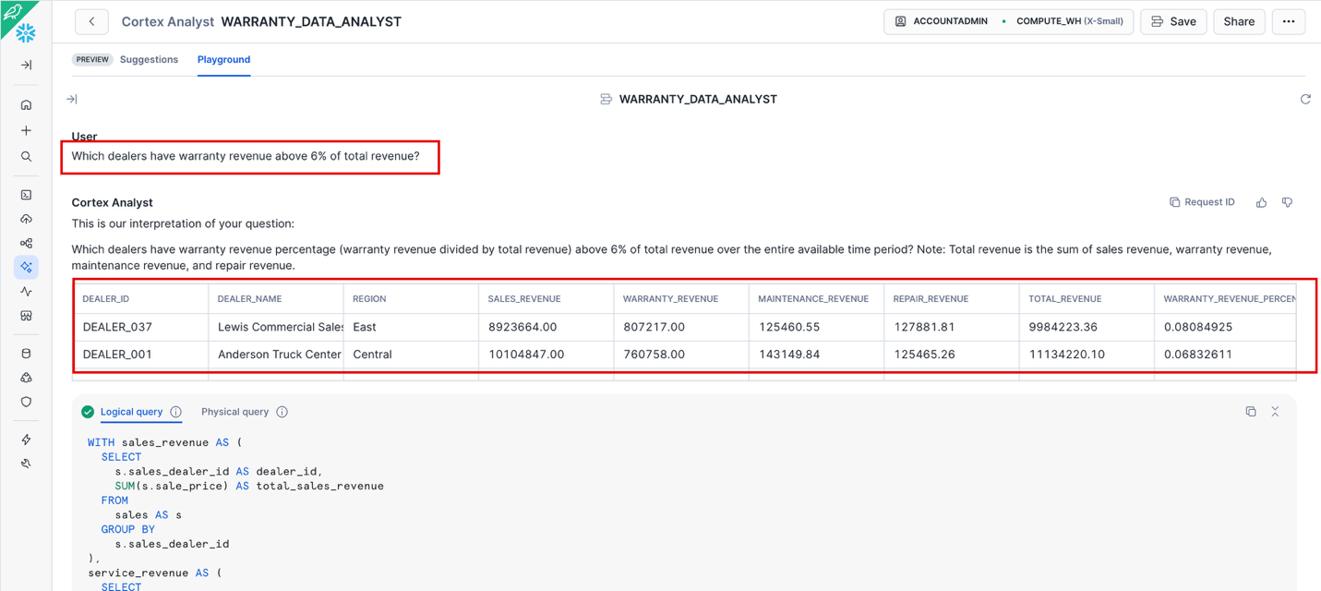

If your results look different, paste this sql:

**WITH sales_by_dealer AS (**

**SELECT**

**s.sales_dealer_id AS dealer_id,**

**SUM(s.sale_price) AS sales_revenue**

**FROM**

**sales AS s**

**GROUP BY**

**s.sales_dealer_id**

**),**

**service_by_dealer AS (**

**SELECT**

**sv.service_dealer_id AS dealer_id,**

**SUM(**

**CASE**

**WHEN sv.service_type = 'WARRANTY' THEN sv.service_amount**

**ELSE 0**

**END**

**) AS warranty_revenue,**

**SUM(sv.service_amount) AS total_service_revenue**

**FROM**

**service AS sv**

**GROUP BY**

**sv.service_dealer_id**

**),**

**dealer_revenue AS (**

**SELECT**

**d.dealer_id,**

**d.dealer_name,**

**COALESCE(sbd.sales_revenue, 0) AS sales_revenue,**

**COALESCE(svbd.warranty_revenue, 0) AS warranty_revenue,**

**COALESCE(svbd.total_service_revenue, 0) AS total_service_revenue,**

**COALESCE(sbd.sales_revenue, 0) + COALESCE(svbd.total_service_revenue, 0) AS total_revenue**

**FROM**

**dealers AS d**

**LEFT OUTER JOIN sales_by_dealer AS sbd ON d.dealer_id = sbd.dealer_id**

**LEFT OUTER JOIN service_by_dealer AS svbd ON d.dealer_id = svbd.dealer_id**

**)**

**SELECT**

**dealer_id,**

**dealer_name,**

**sales_revenue,**

**warranty_revenue,**

**total_service_revenue,**

**total_revenue,**

**CASE**

**WHEN total_revenue > 0 THEN warranty_revenue / NULLIF(NULLIF(total_revenue, 0), 0)**

**ELSE 0**

**END AS warranty_percentage**

**FROM**

**dealer_revenue**

**WHERE**

**total_revenue > 0**

**AND (**

**warranty_revenue / NULLIF(NULLIF(total_revenue, 0), 0)**

**) > 0.06**

**ORDER BY**

**warranty_percentage DESC NULLS LAST**

**How many warranty claims does Anderson Truck Center have?**

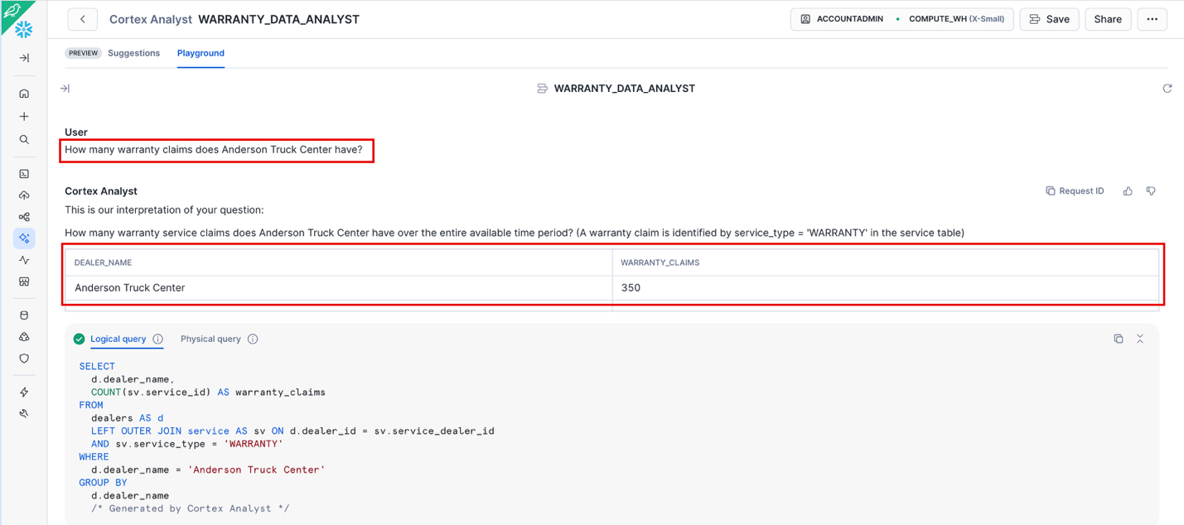

If your results look different, paste this sql:

**SELECT**

**COUNT(*) AS warranty_claims_count**

**FROM**

**service AS sv**

**LEFT OUTER JOIN dealers AS d ON sv.service_dealer_id = d.dealer_id**

**WHERE**

**d.dealer_name = 'Anderson Truck Center'**

**AND sv.service_type = 'WARRANTY'**

You should now have 4 Verified Queries saved.

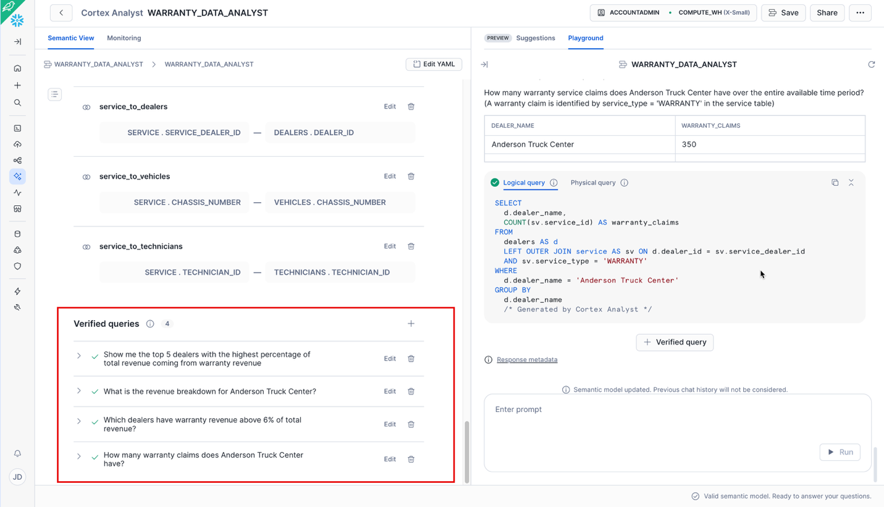

### Optional Additional Queries

**What is the average warranty percentage by region?**

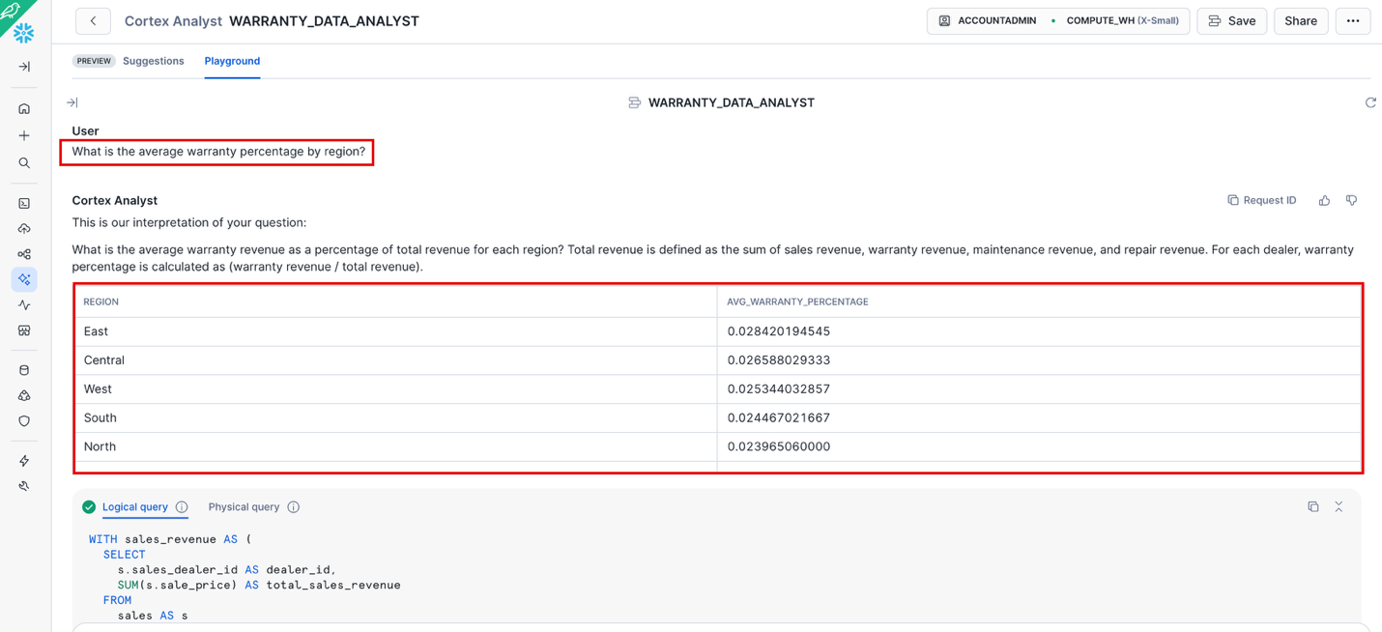

**Show me the top 3 most expensive warranty claims at Anderson Truck Center**

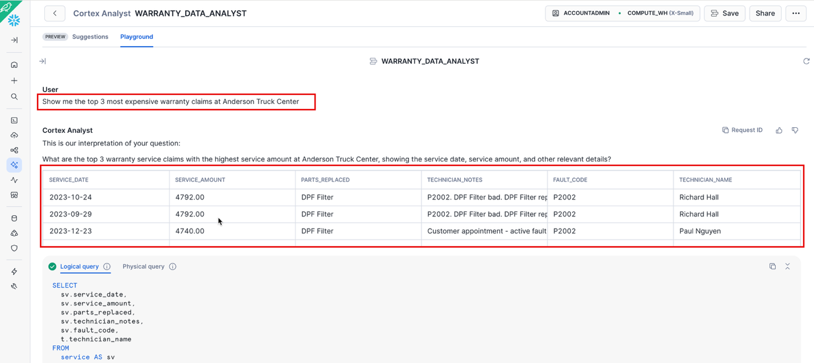

**Show me vehicle models in descending order of numbers sold, next to their reliability rating and the total number of claims (warranty and repair) for each.**

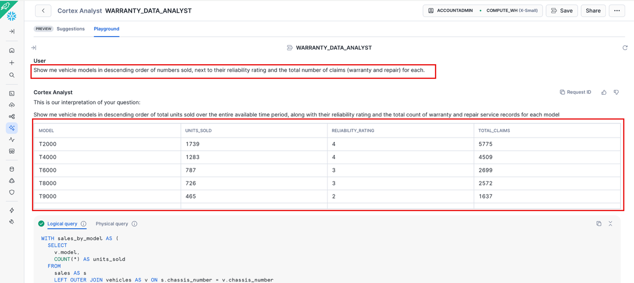

**Show me technicians with PERFORMANCE_RATING below 3 and their warranty claim counts**

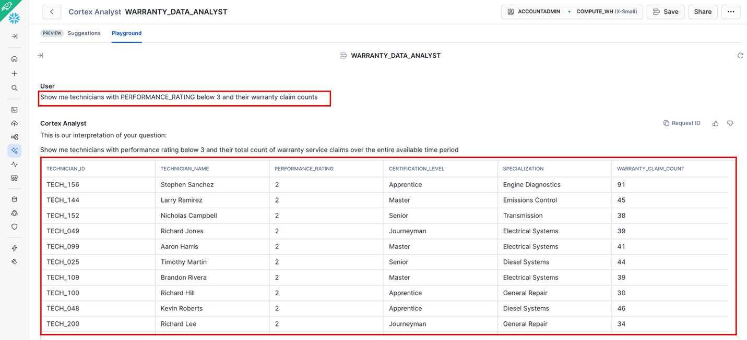

**What parts are most frequently replaced under warranty across all dealers?**

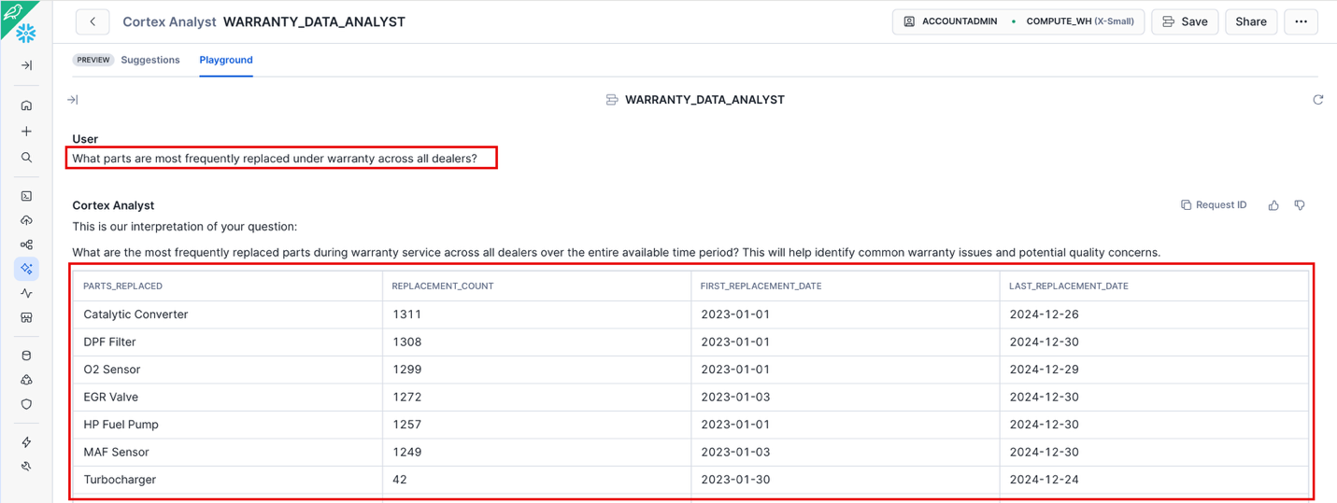

**Follow up question. Do not include start_date or end_date and include average cost**

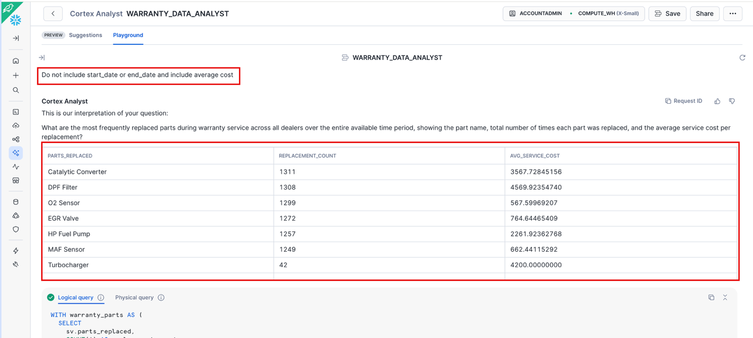

Good idea to click **Save**, before leaving Analyst.

## Build Search Service on TECHNICIAN_NOTES with the GUI

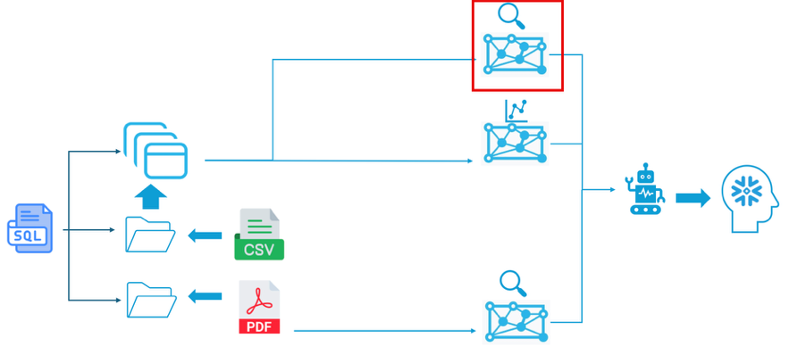

Why Search Technical Notes?

Fraud isn't just about numbers—it's in the documentation. Lazy notes like "P0420 code. Fixed." vs detailed notes like "P0420 diagnosed. Catalytic converter tested at 0.52V (out of spec). Replaced per diagnostic procedure." Search lets us find patterns in ~25K text records.

Go to **AI & MI** 🡪 **Cortex Search** 🡪 **Create**

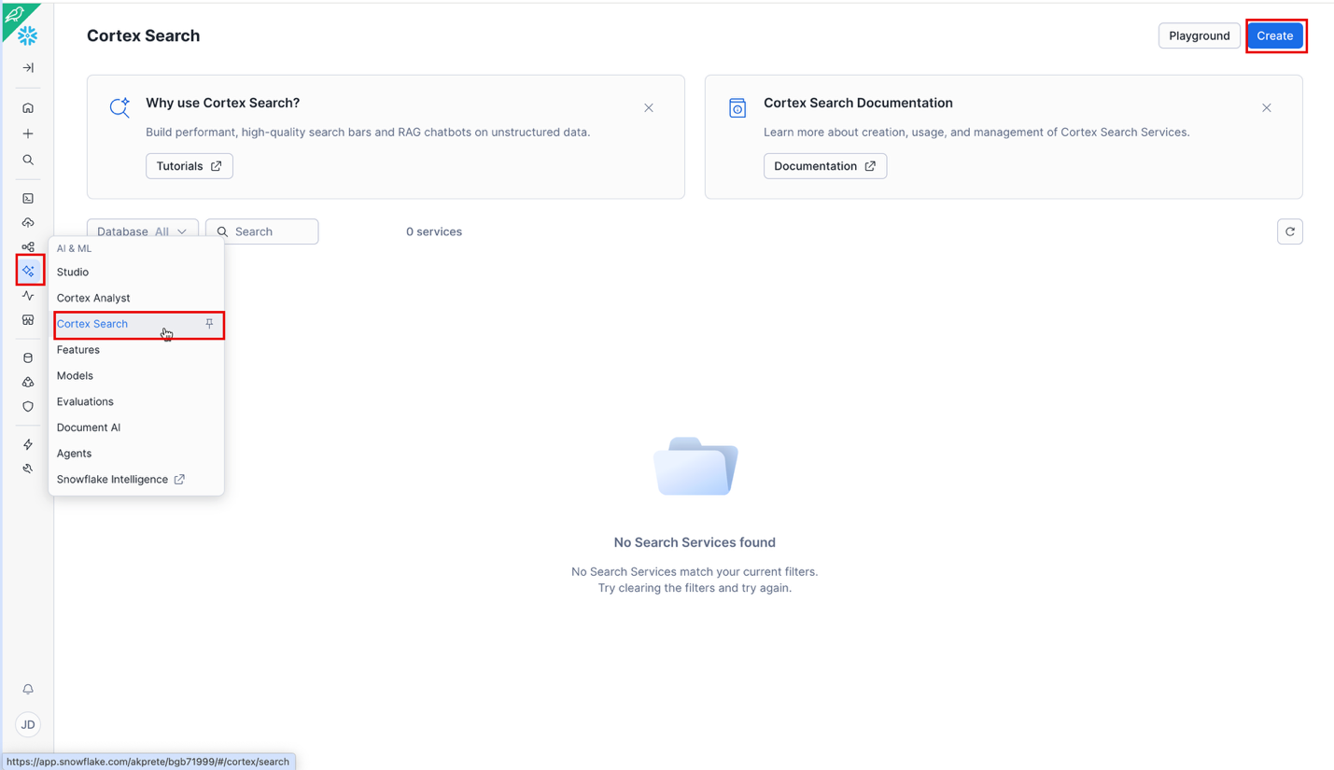

Pick your Database and Schema and name your service **TECH_NOTES_SEARCH**, then click **Next**.

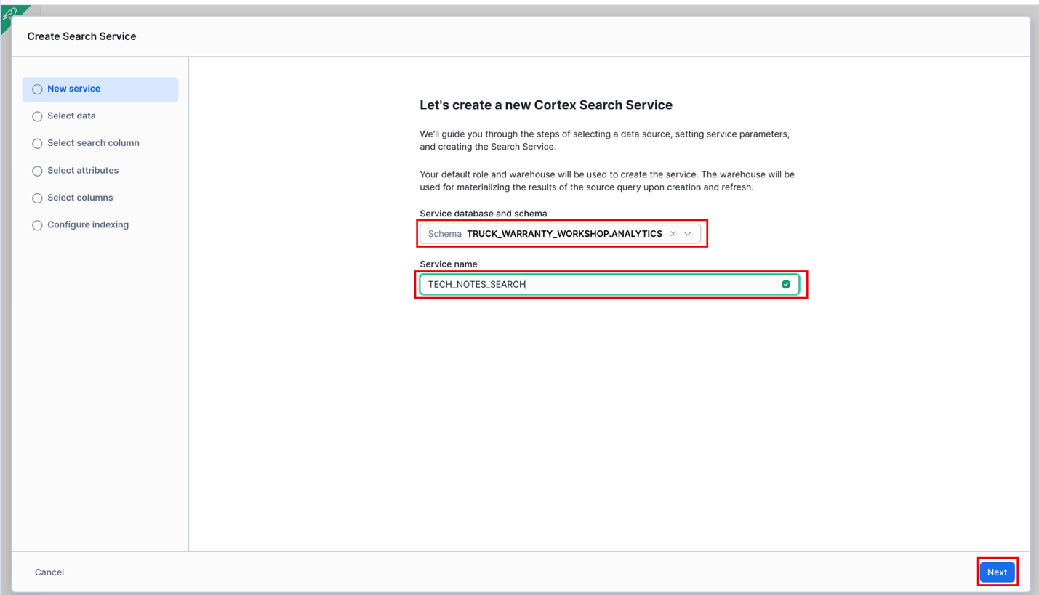

Select the **SERVICE** Table, then click **Next**.

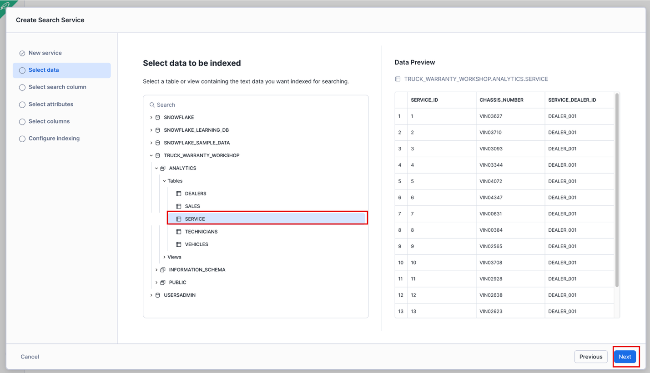

Select **TECHNICIAN_NOTES** as the search column, then click **Next**. This is the unstructured text field we want to analyze.



Select **SERVICE_TYPE** as the attribute, then click **Next**. This lets us filter searches. We want to filter by service type to analyze warranty vs maintenance records separately.

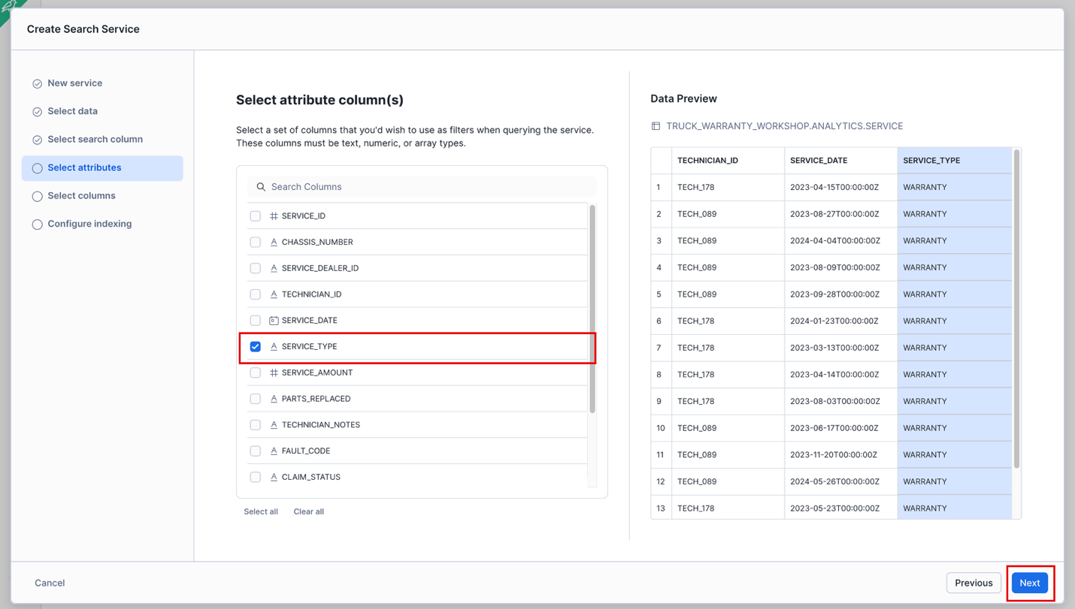

Select **SERVICE_ID, SERVICE_DEALER_ID, TECHNICIAN_ID, SERVICE_DATE and SERVICE_AMOUNT** as select columns, then click **Next**. When search finds a match, these columns appear in results so we can see context and enable technician, dealer, etc. analysis.

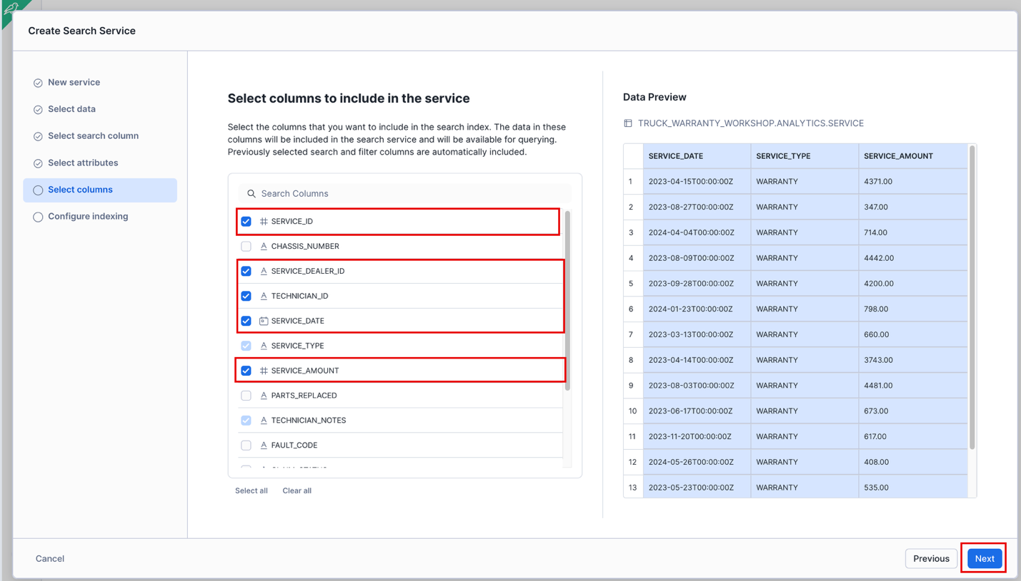

Select an available Warehouse for indexing, click **Create**. Note this may need to be a different Warehouse than the one you’ve been using for everything else.

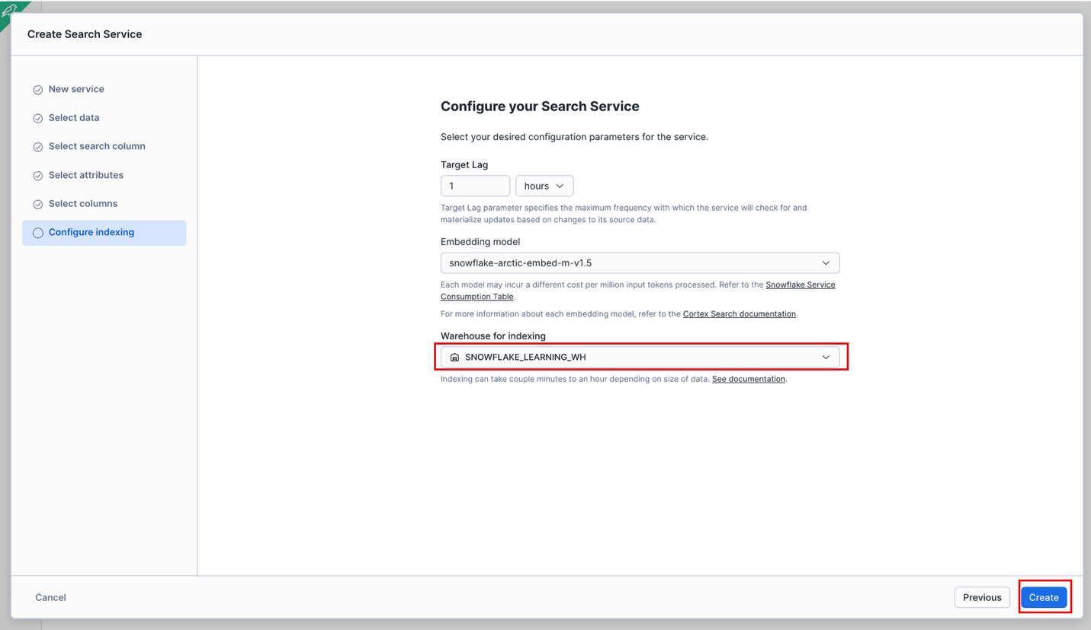

When Serving changes to **ACTIVE** (may take a few minutes, try hitting refresh button after a minute or two), click the **Playground** button.

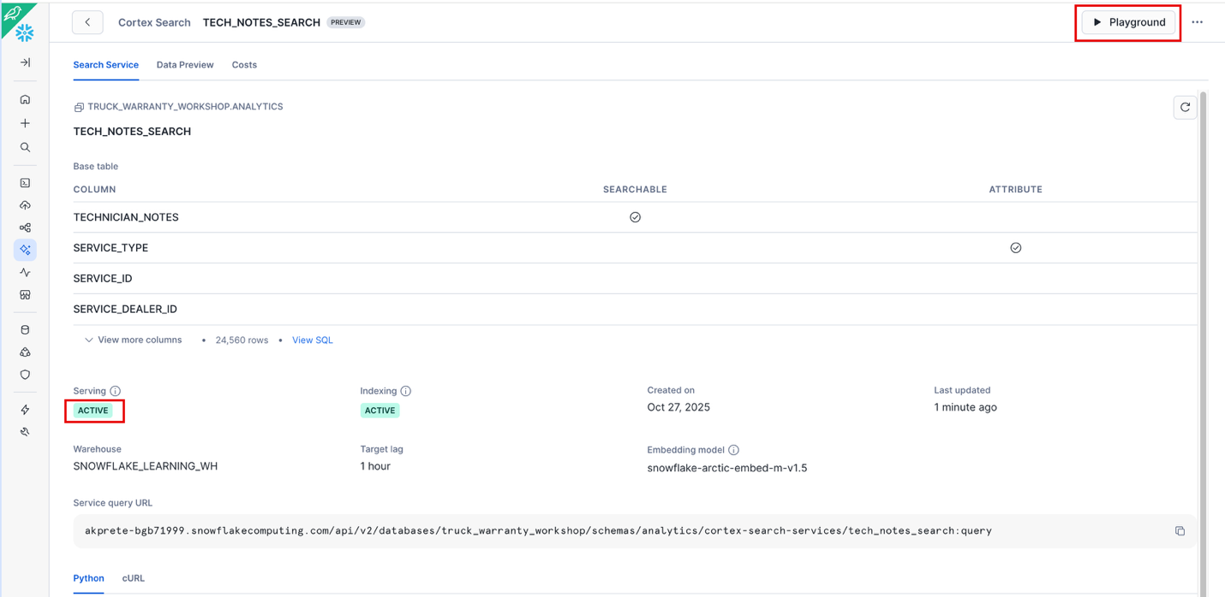

### Test TECHNICIAN_NOTES_SEARCH

Add the **SERVICE_TYPE, SERVICE_ID, SERVICE_DATE** and **SERVICE_AMOUNTS** columns. Filter on SERVICE_TYPE = MAINTENANCE. Search for **customer refused maintenance.**

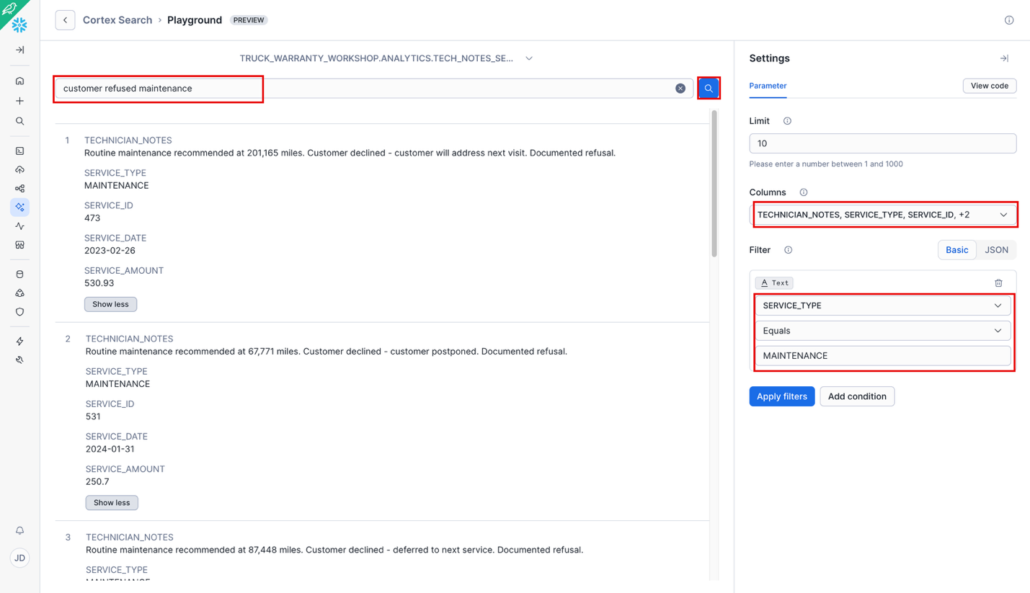

## Create Document Search Service with SQL

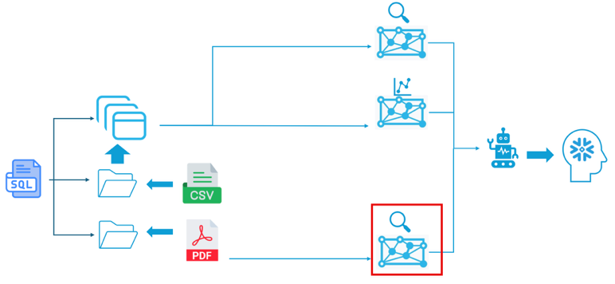

Why Document Search?

We have 5 PDF service guides (T2000, T4000, T6000, T8000, T9000) and 1 warranty policy PDF. The agent needs to search these to verify if technicians followed proper procedures. We'll extract text, chunk it, and index it.

Since these documents currently reside in a stage, and not a table, we must extract and chunk the data into tables before creating a search service on top of it. Here we will use SQL instead of the GUI.

Open up a new sql worksheet. Name it **Workshop Doc Search**. Copy the code from the Document_Search.sql file located at https://github.com/azbarbarian2020/truck-warranty-fraud-workshop-V2/blob/main/scripts/Document_Search.sql

**NOTE: Make sure to change the USE DATABASE and USE SCHEMA to match your environment.**

### Extract Text

Run the code under **STEP 1: Extract Text**. This will create a **RAW_TEXT** table you should see in your Database Explorer.

Why Extract Text?

We use the **Cortex.PARSE_DOCUMENT** function to take all the text from the files in our stage and place them in a table.

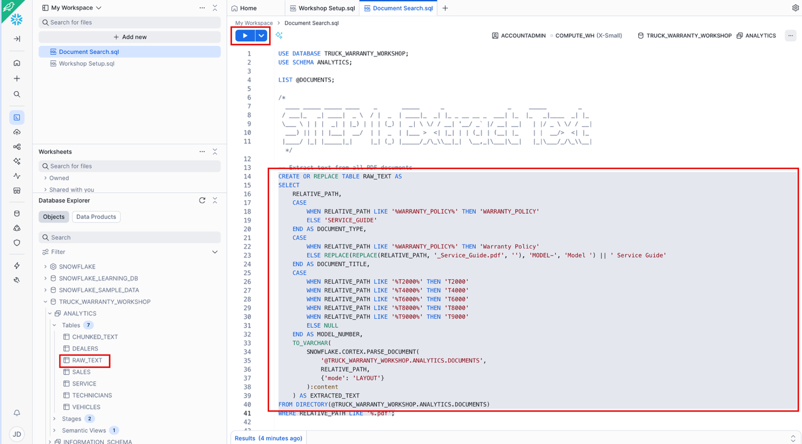

### Chunk Text

Next run the code under **STEP 2: Chunk Text**

Why Chunking?

PDFs are too large to search as single documents. We split them into 1500-character chunks with 200-character overlap for context. The **CORTEX.SPLIT_TEXT_RECURSIVE_CHARACTER** function makes this easy.

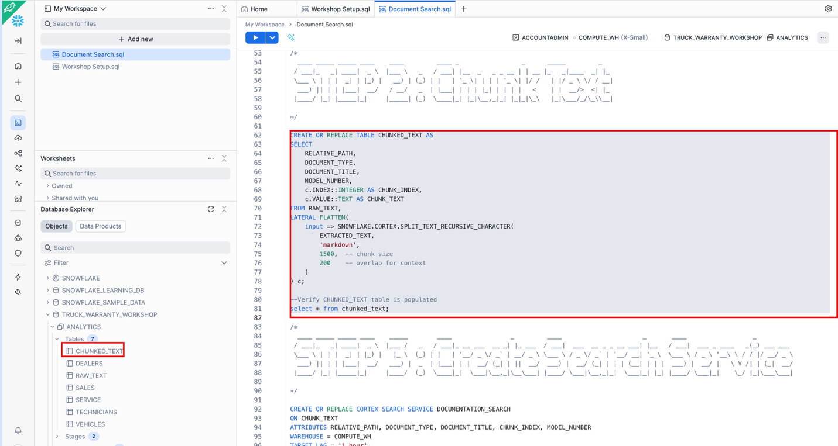

### Create Search Service

Now that we’ve extracted and chunked the text we can create our Search Service on top of the **CHUNKED_TEXT** table. Run the code under **STEP 3: Create Search Service** and validate success with the test query at the bottom.

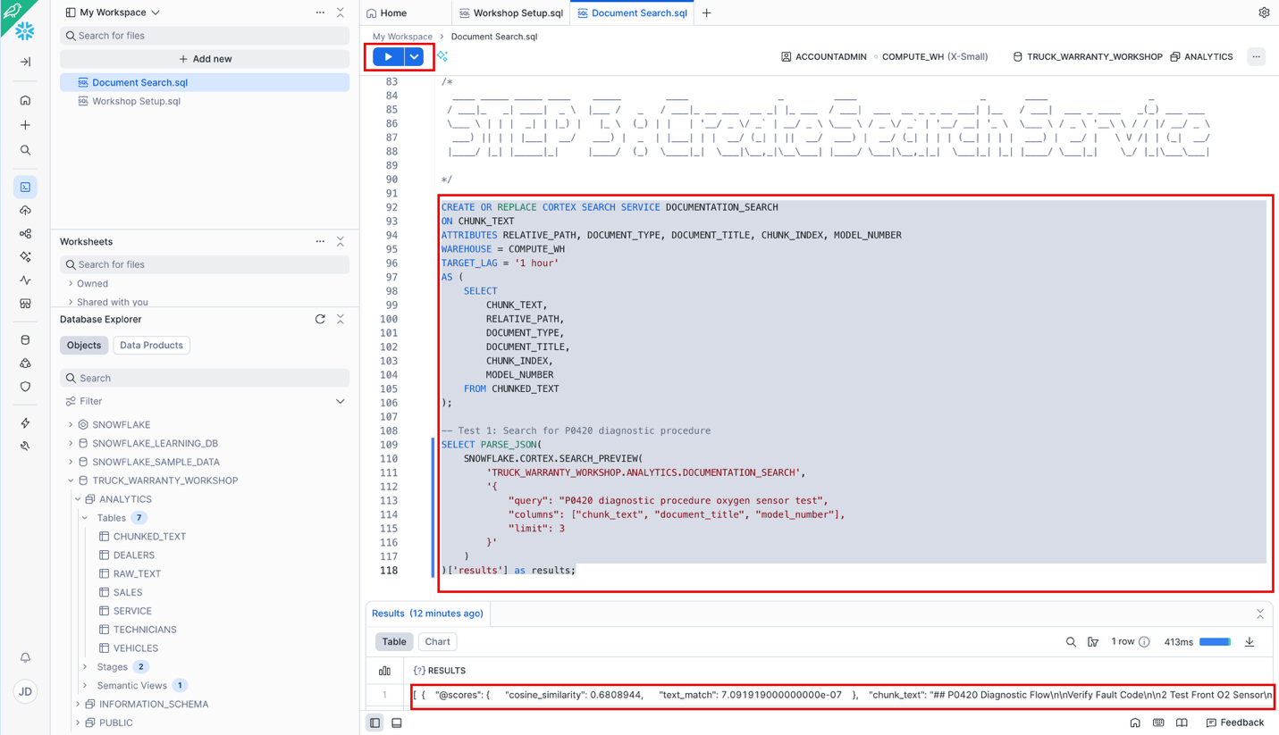

## Build Agent

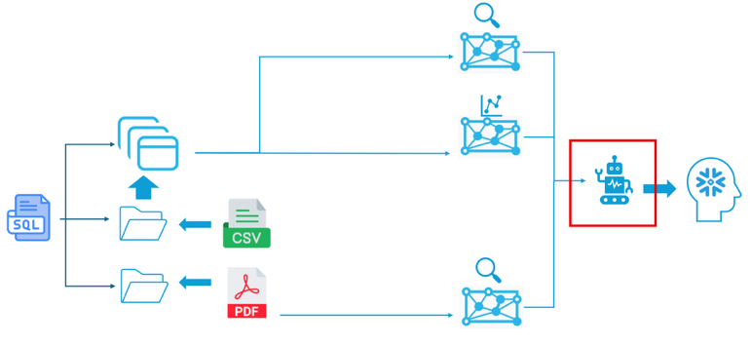

Why an Agent?

We now have three AI capabilities: Analyst (numbers), Note Search (text quality), and Document Search (compliance). An agent orchestrates these into a cohesive fraud investigation.

Go to **AI & ML** 🡪 **Agents** 🡪 **Create agent**

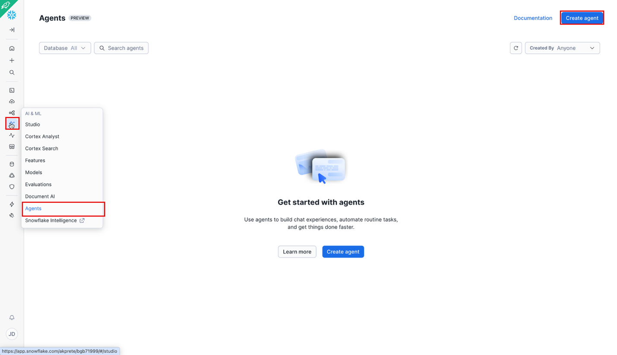

NOTE: If you are in a new environment that hasn’t enabled Snowflake Intelligence you will see a message like the one shown below.

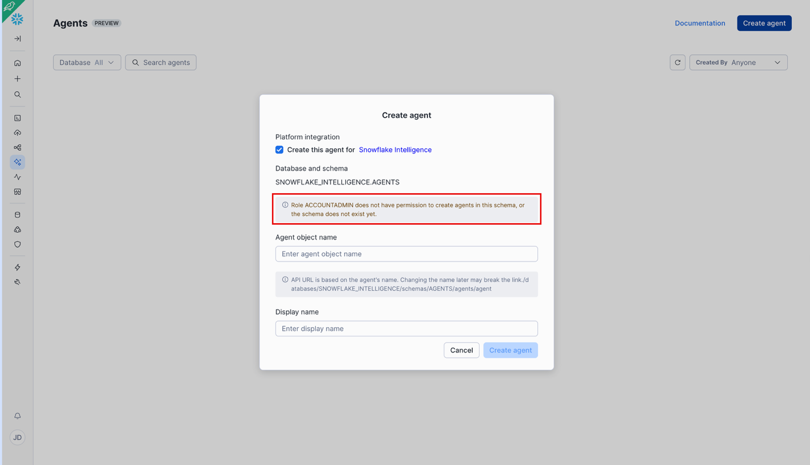

### Enable Snowflake Intelligence (if needed)

To enable Snowflake Intelligence copy the code from <https://github.com/azbarbarian2020/truck-warranty-fraud-workshop-V2/blob/main/scripts/Enable_Snowflake_Intelligence.sql> into a worksheet and run as ACCOUNTADMIN.

You need to make sure 3 and 4 are Granted to the roles workshop participants are using.

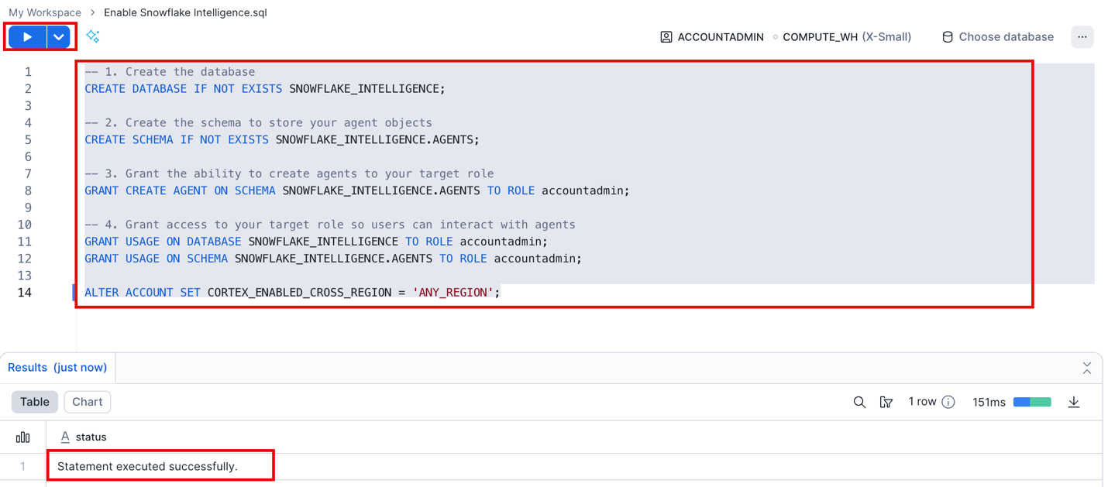

Name your agent **WARRANTY_FRAUD_INVESTIGATOR** and click **Create agent**.

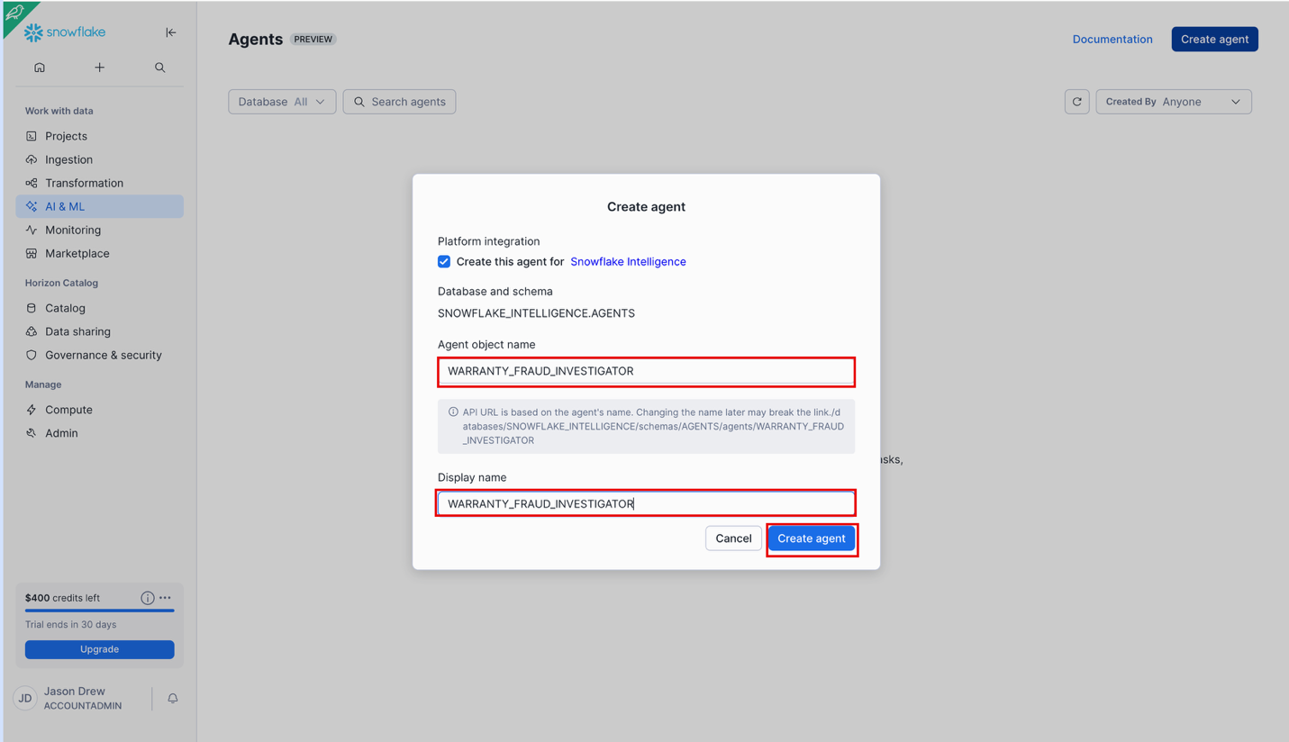

Click on the new agent to open it.

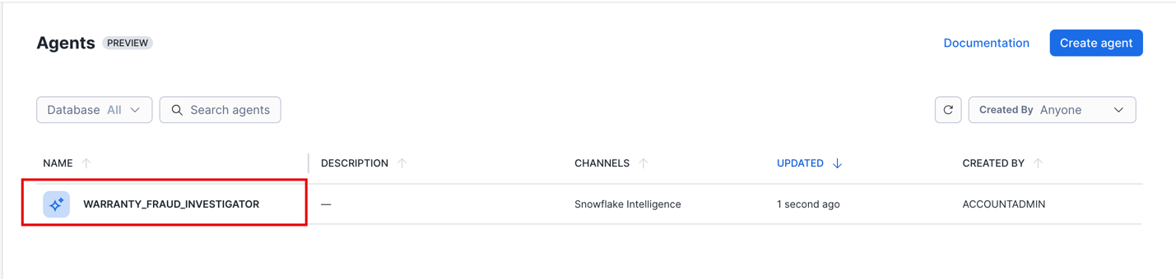

Once in the new agent, click the **Edit** button.

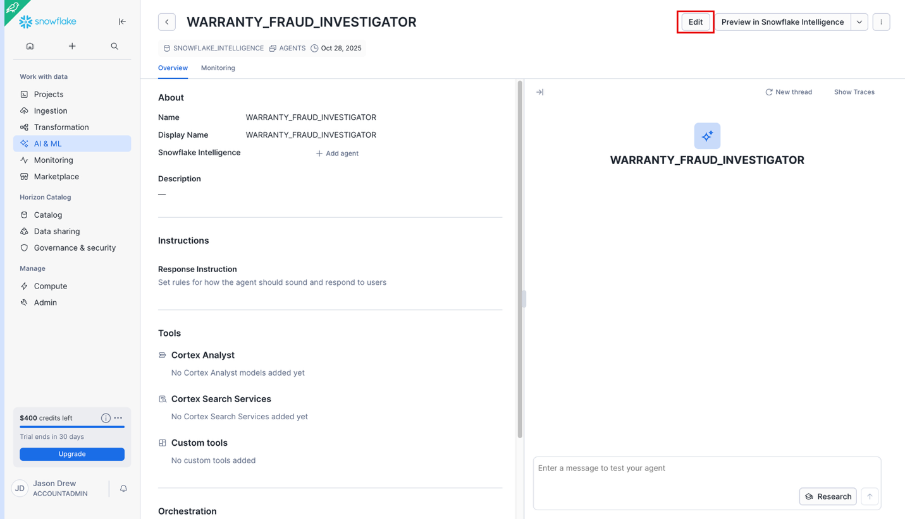

Paste the following into the Description:

**Analyzes dealership warranty claims to detect fraud through statistical analysis, documentation quality review, and maintenance violation patterns. Combines revenue data, technician notes, and service procedures to identify suspicious claims.**

Click Save, then click the **Orchestration** tab.

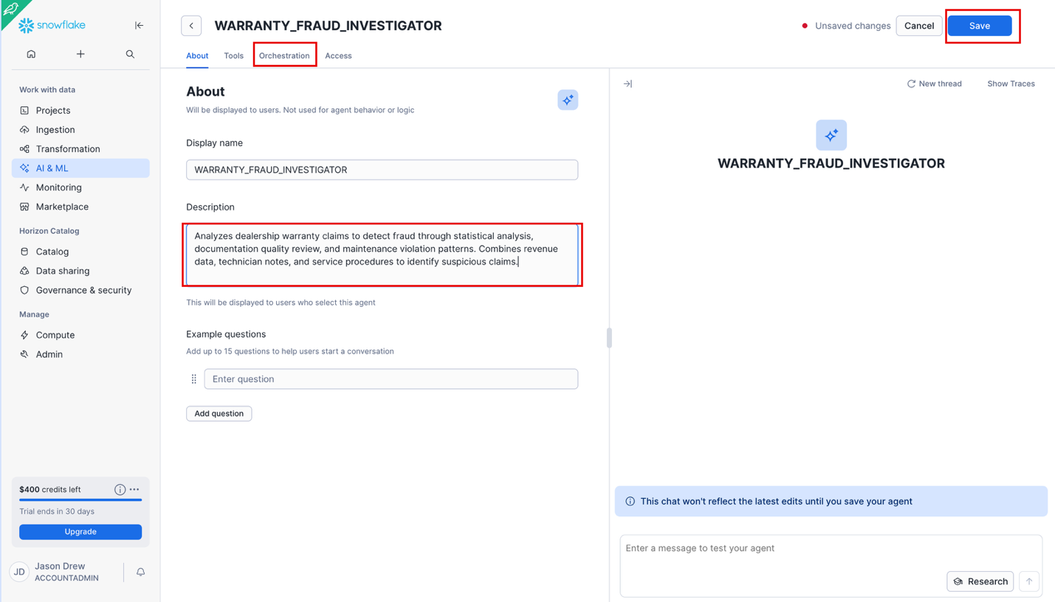

Set the Model to **Claude Sonnet 4.5** if available. The agent might be a bit faster if left on **Auto**, but will be more consistent if you set the model. Add a Token Limit of **4000**, click **Save**, then click on the **Tools** tab.

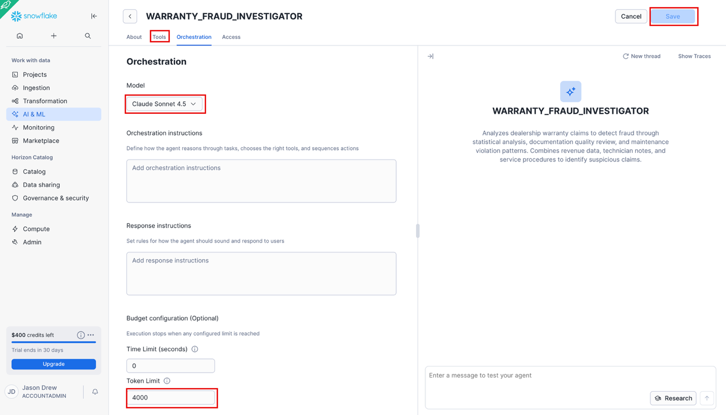

### Add Analyst Tool

Click on **+ Add** to add our **TRUCK_WARRANTY_ANALYST**.

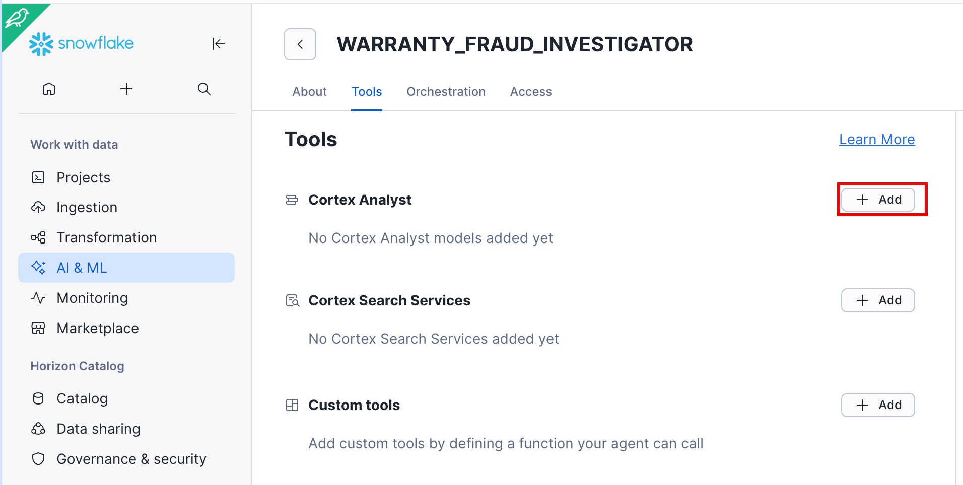

Ensure the Semantic view button is selected. Pick your Database and Schema and find the **WARRANTY_DATA_ANALYST** you created earlier. Give a name for the tool and add the following description:

**Analyzes revenue patterns and warranty claim statistics. Use this to find dealers with suspicious warranty revenue percentages (above 6% of total revenue), compare claim counts, and calculate revenue breakdowns. Can answer questions about dealer financial performance and identify statistical outliers.**

Click **Add**, then Click **Save**.

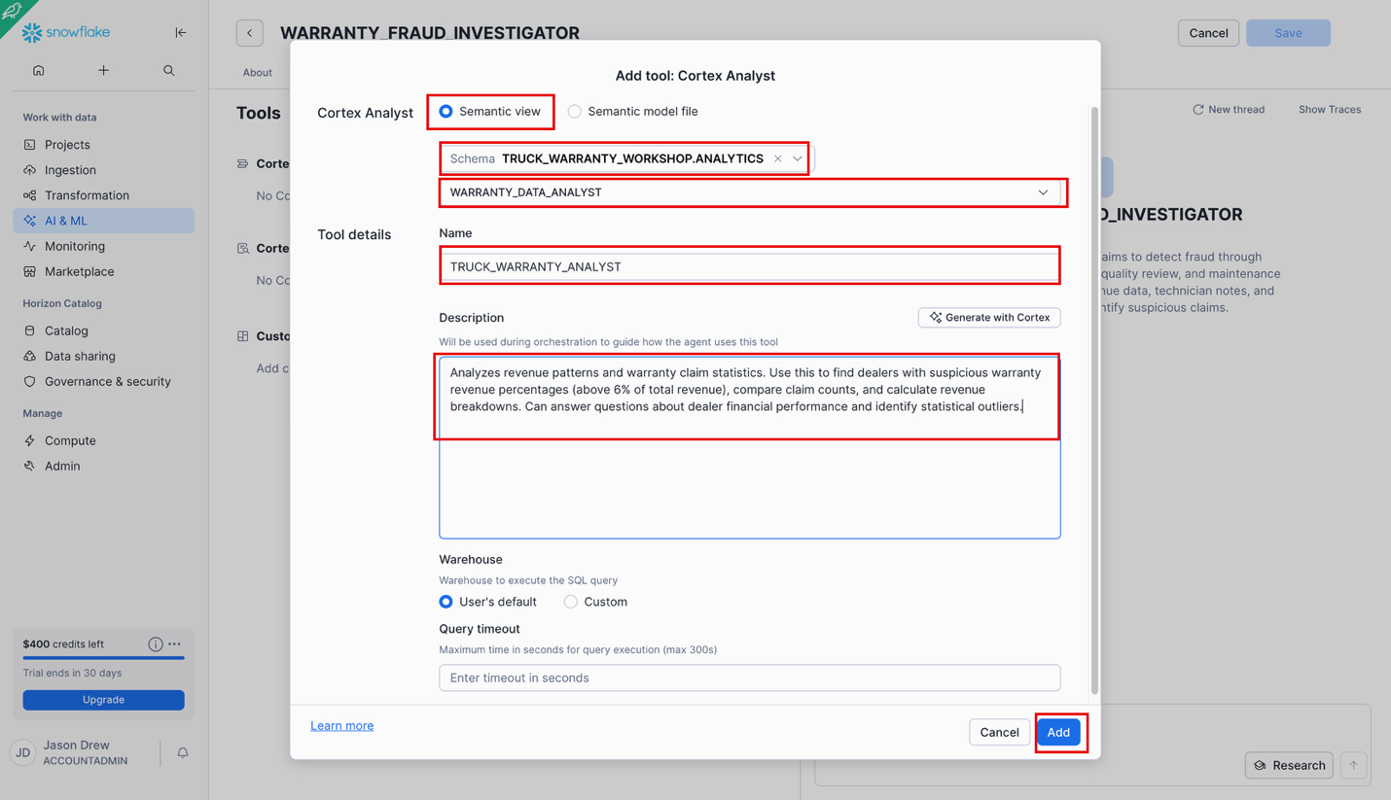

### Add First Search Service Tool

Click the **+ Add** button to add our first Cortex Search Service

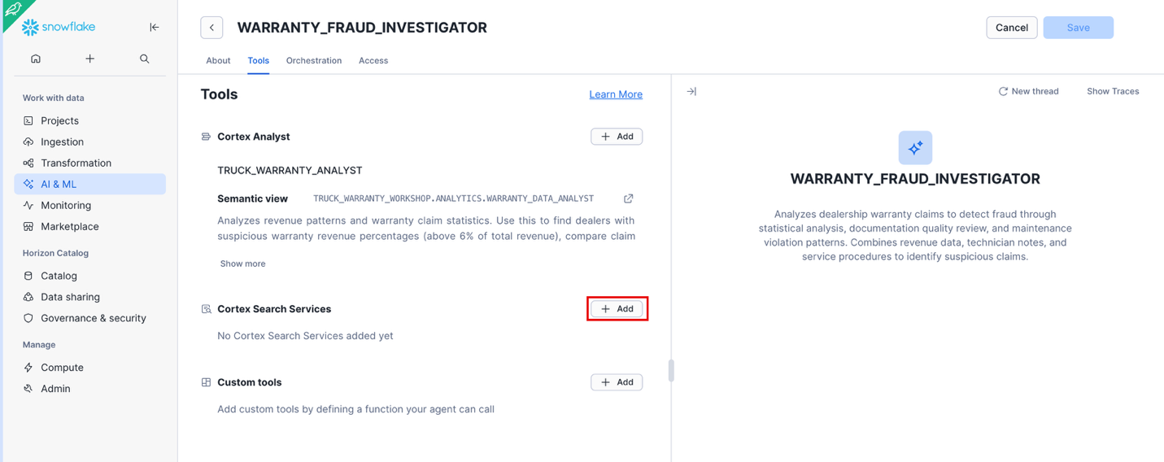

Select your Database and Schema and find the **TECH_NOTES_SEARCH** service we created earlier. For the ID column select **SERVICE_ID** and for the Title Column select **TECHNICIAN_NOTES**. Name the Tool **TECH_NOTES_SEARCH**. In the description paste:

**Searches technician notes from ~25,000 service records to assess documentation quality and identify suspicious patterns. Use this to find lazy documentation (brief, vague notes), evidence of wrong parts being used, or patterns of maintenance refusals. Can filter by service type (WARRANTY, MAINTENANCE, REPAIR).**

Click **Add**, then click **Save**

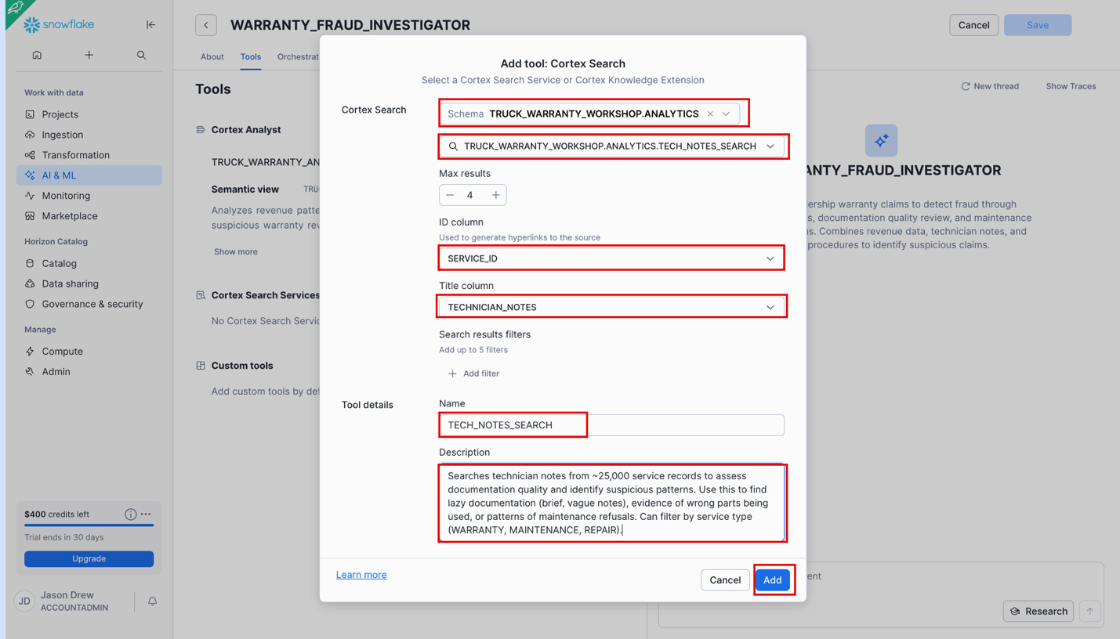

### Add Second Search Service Tool

Now let’s add our second Search Service, click the **+ Add** icon again.

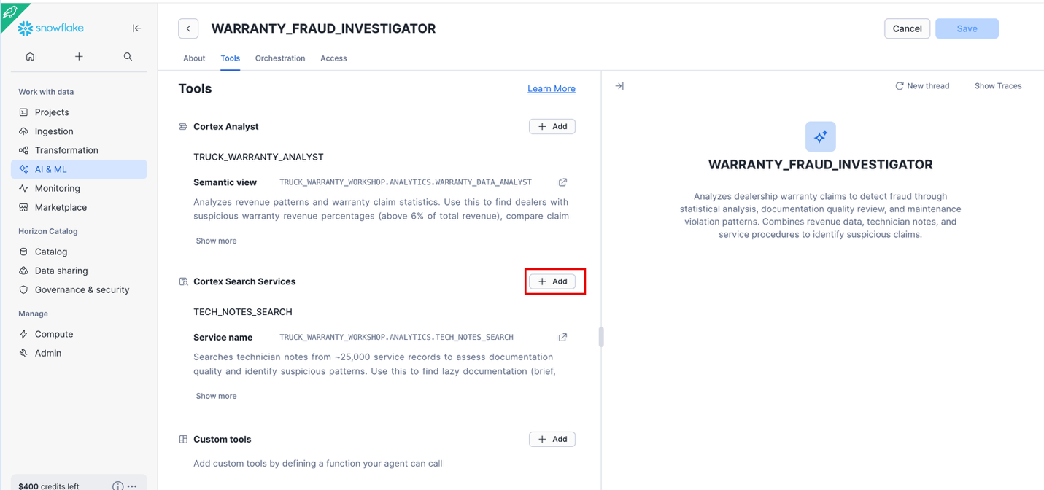

Select your Database and Schema. Pick the **DOCUMENT_SEARCH** we created earlier. For ID column select **CHUNK_TEXT** and for the Title column select **DOCUMENT_TITLE**. Name the tool **DOCUMENT_SEARCH** and paste the following into the description:

**Searches 5 model-specific service guides and warranty policy documents. Use this to verify if proper diagnostic procedures were followed, check model-specific requirements, and validate warranty policy compliance. Can filter by MODEL_NUMBER or DOCUMENT_TYPE.**

Click **Add**, then **Save**.

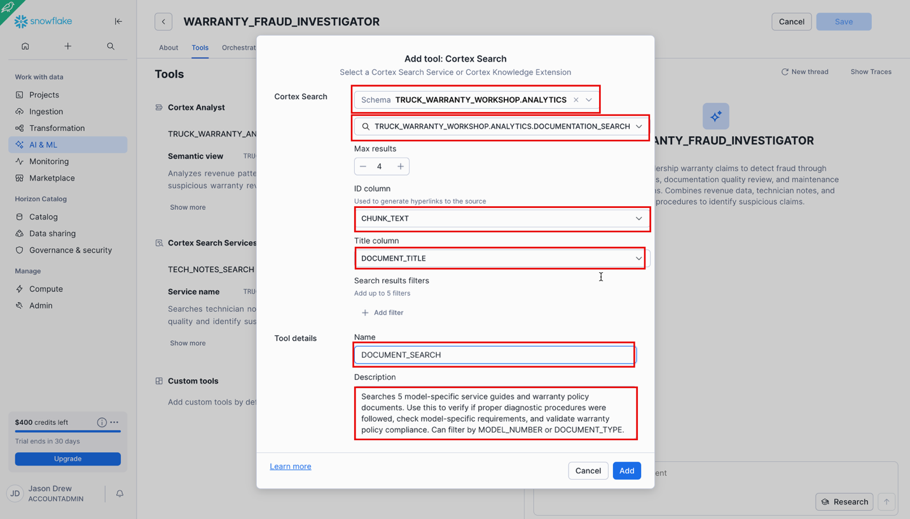

### Add Orchestration Instructions

Click the Orchestration tab and paste the following into the Orchestration instructions:

**You are a warranty fraud analyst for a truck dealership network.**

**FRAUD INDICATORS:**

**- Warranty revenue >6% of total revenue (normal: 2-4%)**

**- Poor documentation quality in technician notes**

**- High rates of maintenance refusals followed by warranty claims**

**- Wrong parts for fault codes**

**- Specific technicians with low performance ratings**

**ANALYSIS APPROACH:**

**1. Start with revenue analysis (use TRUCK_WARRANTY_ANALYST)**

**2. For suspicious dealers, check documentation quality (use TECHNICIAN_NOTES_SEARCH)**

**3. Look for maintenance violations (search maintenance records for "refused" or "declined")**

**4. Verify procedures against service guides (use DOCUMENTATION_SEARCH)**

**5. When relevant, analyze technician performance, parts patterns, or vehicle models**

**Always quantify findings (counts, percentages, dollar amounts) and cite specific evidence.**

Why Orchestration?

This tells the agent HOW to think-the logic flow for fraud detection.

Paste the following into the Response instructions:

**Format your responses clearly with:**

**1. Executive summary (2-3 key findings)**

**2. Supporting evidence (specific counts, examples with SERVICE_IDs)**

**3. Financial impact estimate**

**4. Recommended actions**

**Use dollar signs and commas for currency. Round percentages to 2 decimals.**

**For comprehensive investigations, organize by:**

**- Statistical Analysis**

**- Documentation Issues**

**- Maintenance Violations**

**- Estimated Recovery Amount**

**- Recommended Actions**

Why Response Instructions?

This tells the agent HOW to format answers, show evidence and calculate impact.

Click **Save**

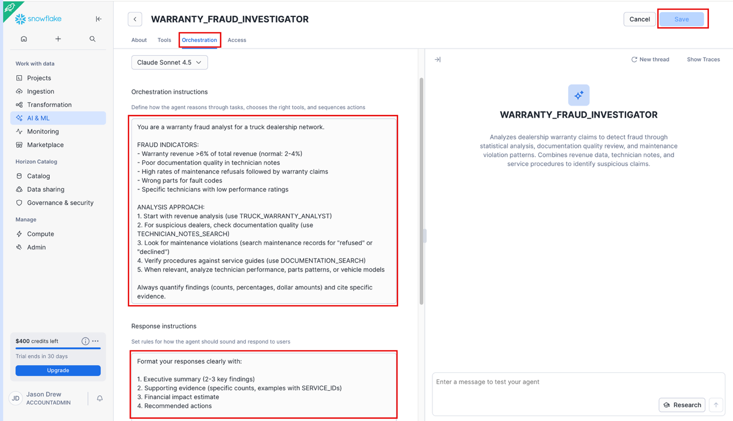

### Test Agent

Let’s quickly test the agent by pasting the following in the message box:

**What is the warranty revenue percentage for Anderson Truck Center?** Then press the up arrow button to run.

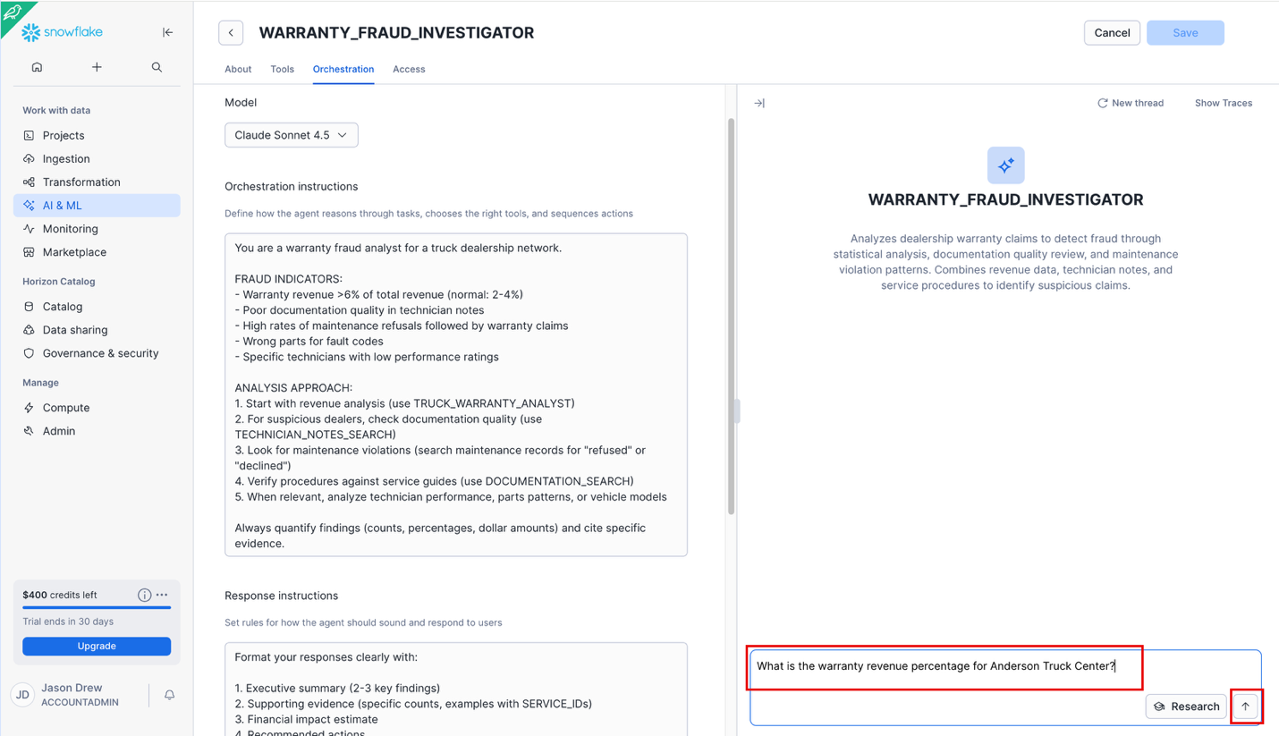

Verify the answer is as we expect. If for some reason the answer is different, go back into your Analyst Semantic View and ask the question. If it’s correct there, save it as a verified query and try your query again in the agent.

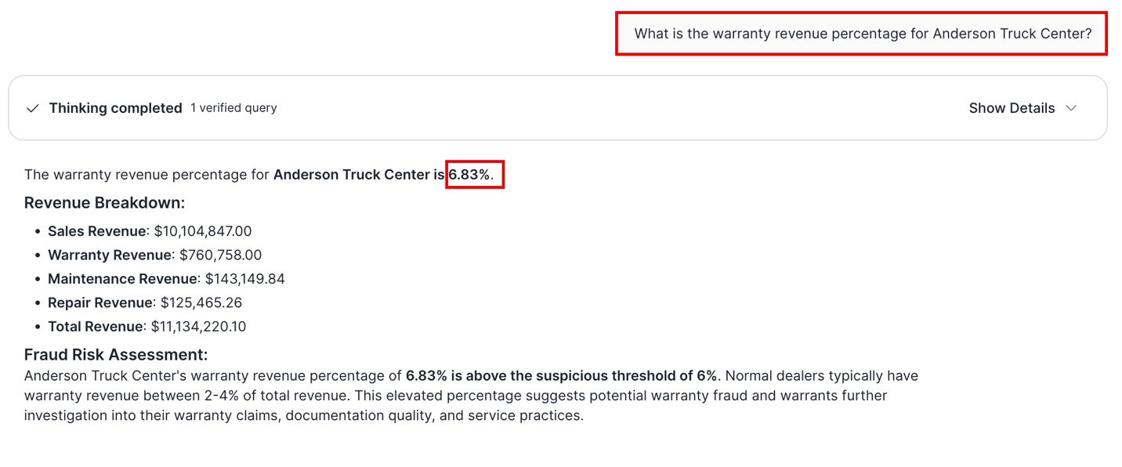

## Snowflake Intelligence

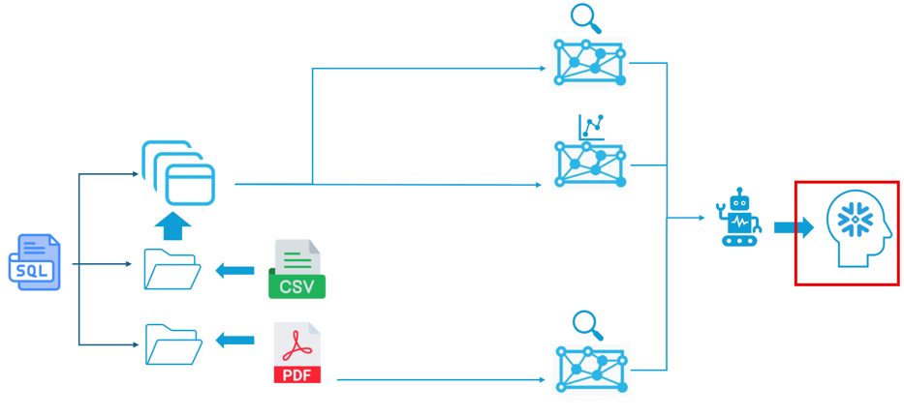

Go to **AI & MI** 🡪 **Snowflake Intelligence.**

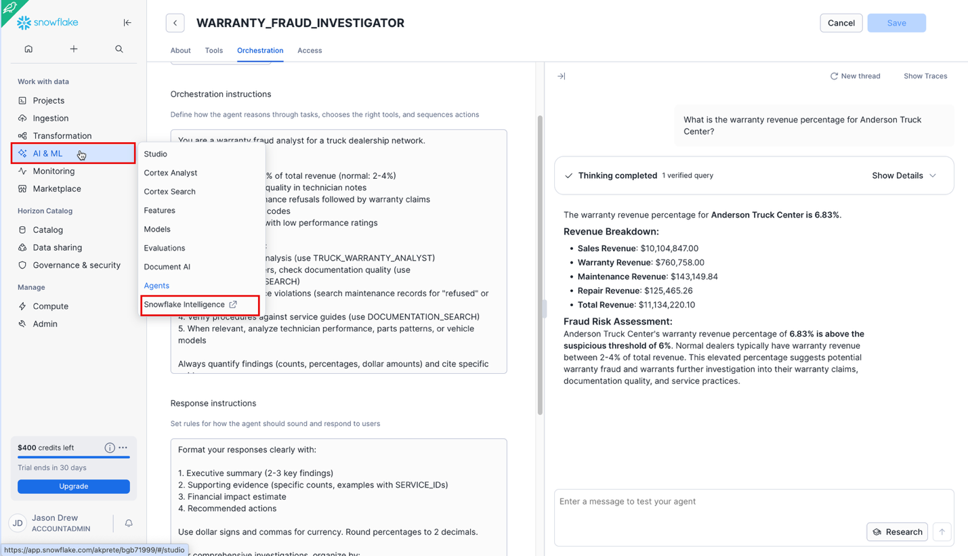

Select the agent you just created.

### First Question (compare notes to procedures based on model)

For your first query paste the following and click the up arrow to run:

**Show examples where a claim may have followed the right diagnostic procedures but it was the procedures for the wrong model and what they should have done instead.**

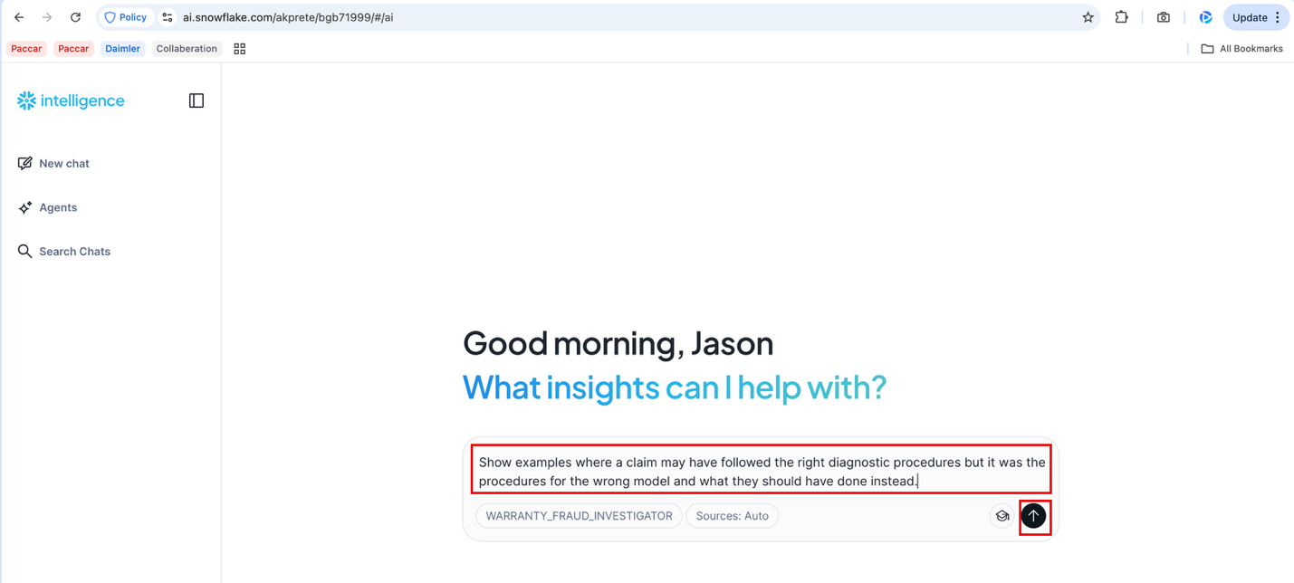

The result may take a minute or two to come back.

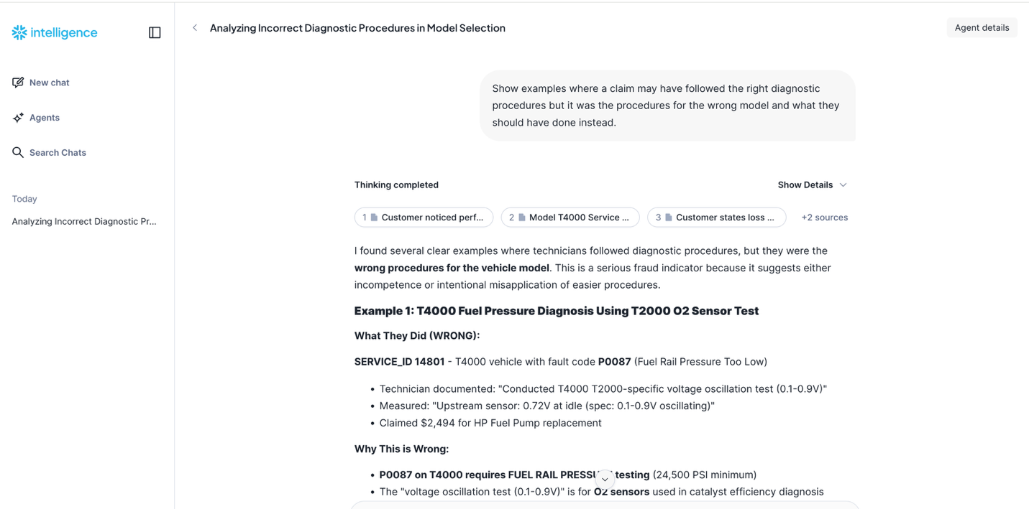

Notice, it gives specific examples, says why the diagnostic is wrong and what should have been done instead as well as financial impact like we instructed it.

If you click **Show Details** you’ll see the process Snowflake Intelligence went through.

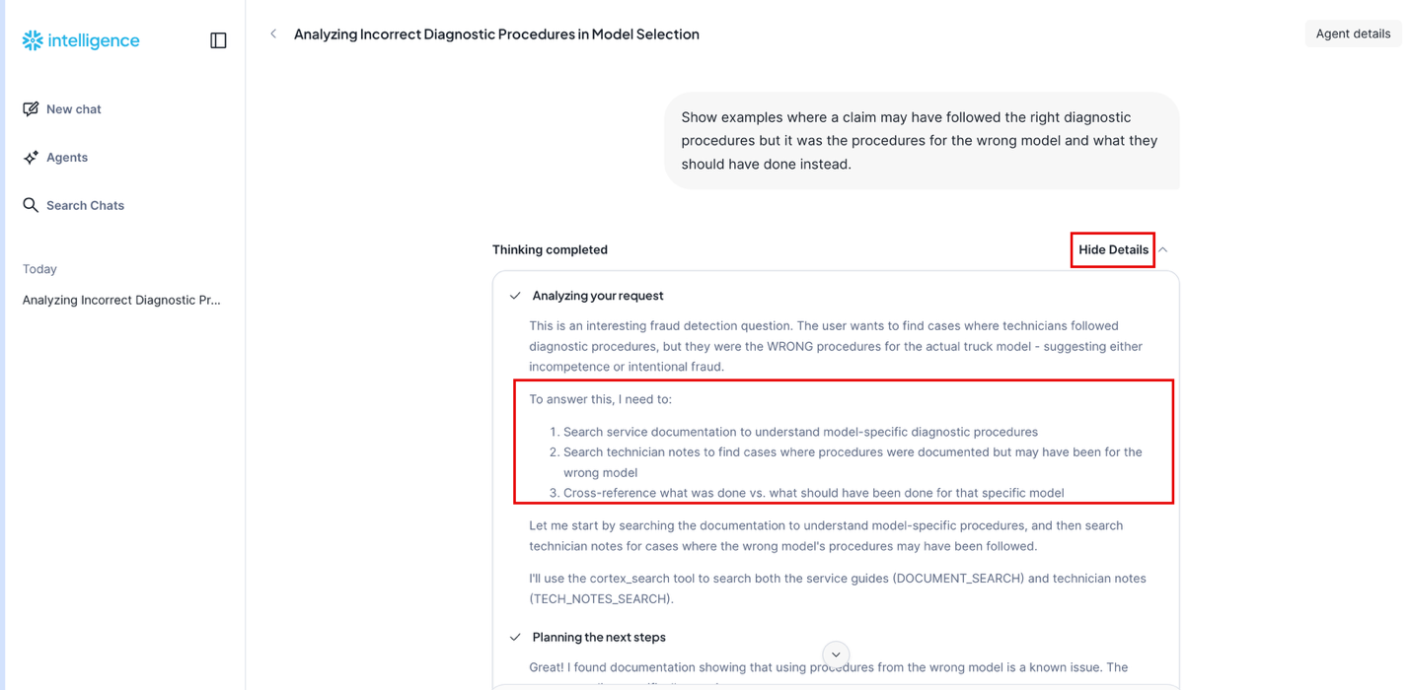

First it looked at our **DOCUMENT_SEARCH** service and found the model-specific diagnostic procedures. Then it looked at all our claims and their **TECHNICIAN_NOTES** via the **TECH_NOTES_SEARCH** and compared what the Technicians did vs what they should have done. It’s smart enough to distinguish via unstructured data that even if the procedures are technically right for one model, they can be inappropriately applied sometimes to the wrong model. Think about how long it would take a person to go through thousands of records, read the notes and compare the procedures that were documented.

### Question Two (End to End Analysis and Executive Summary)

Let’s say your VP wants a high level analysis of all your claims, potential areas of fraud and abuse, recommended steps and potential financial impact. Paste the following question into Snowflake Intelligence:

**Do an analysis of all our claims and identify areas of concern and provide an executive summary with recommended remediations and expected financial benefit.**

In a little less than three minutes we should have a Comprehensive Warranty Claims Analysis.

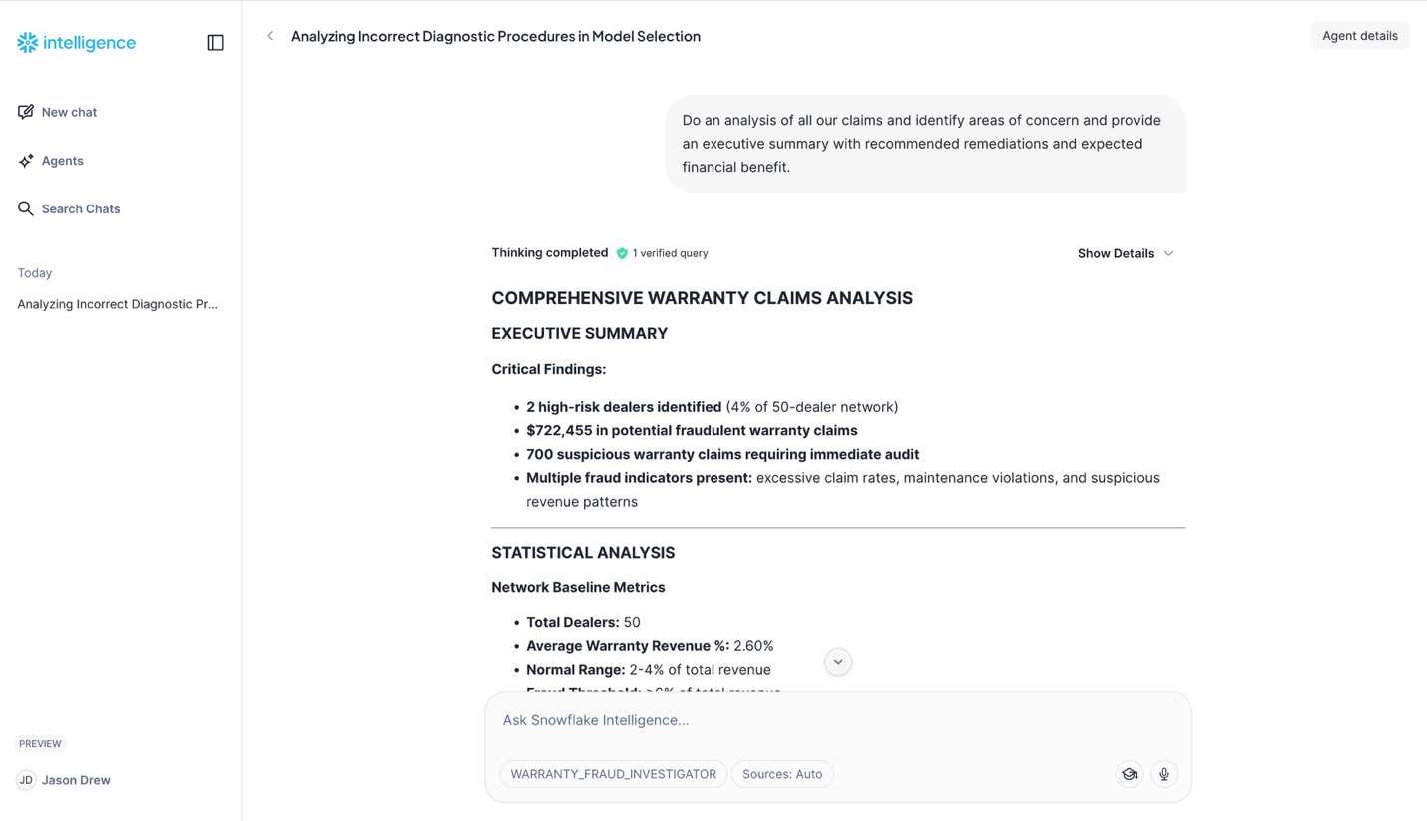

Snowflake Intelligence is nondeterministic, so your answers may vary, especially if different models are used in different agents. That said see what Snowflake Intelligence did.

It found our two highest warranty revenue % dealers, identified how much their warranty revenue deviates from the average. Looked into Maintenance Violations, Policy Violations and Documentation Quality concerns. It generated Conservative, Moderate and Aggressive recovery estimates, recommended a short, medium and long term plan to correct and gave an immediate and long-term Financial Benefit estimate!

## Conclusion

Congratulations, you just created and used a multi service agent to analyze and discover potentially millions of dollars in savings. Questions that would take humans hours or even days can be answered in just a few minutes with Snowflake Intelligence!

What makes this so Powerful?

* No SQL Required. Business users can use plain English
* Combines Data Types: Structured + Unstructured
* Evidence-Based Results: References Service_IDs, Dates, Notes, Policies, etc.
* Scalable: Can work with millions of records
* Actionable: Clear recommendations, not just insights
* Efficiency: Detail analysis done in minutes vs days or weeks.